Parent-Student Handbook 2026-2027

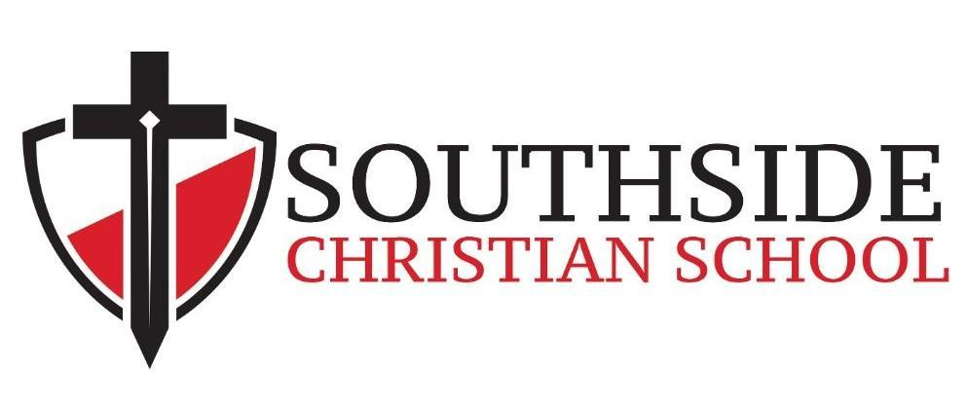

120 Discipleship Drive
Clayton, NC 27520

Revised 07/23/2026

“Equipping Warriors for Christ through Kingdom Education”

SOUTHSIDE CHRISTIAN SCHOOL OVERVIEW

2026-27 School Theme

“Christ Reigns"
For by him all things were created, in heaven and on earth, visible and invisible, whether thrones or dominions or rulers or authorities—all things were created through him and for him. And he is before all things, and in him all things hold together. Colossians 1:16-17

Nondiscrimination Policy

Southside Christian School admits students of any race, color, national and ethnic origin to all the rights, privileges, programs, and activities generally accorded or made available to students at the school. It does not discriminate on the basis of race, color, national and ethnic origin in administration of its educational policies, admissions policies, scholarship and loan programs, and athletic and other school-administered programs.

Southside Christian School does reserve the right to select students on the basis of academic performance, religious commitment, philosophical compatibility, and willingness to cooperate with the Southside Christian School administration and abide by its policies.

Mission
Partnering with Christian families to prepare students spiritually, academically, and socially to make a positive impact for Christ, serving as leaders wherever God calls them

Vision
Transforming lives through Christ-centered discipleship and excellence in education

Statement of Faith
We hold fast to the Biblical truth that the one living and true God exists eternally as a Trinity of three distinct Persons—Father, Son, and Holy Spirit. They are co-equal in power, co-eternal in glory, and united in their one undivided Godhead.

School Motto, Colors and Mascot
- School Motto: “Excellence through Absolute Truth in Christian Education”
- School Colors: Red, Black and White
- School Mascot: Warriors
- Warrior Code: I am an SCS Warrior. I will put on the whole armor of God to help me walk the path of righteousness. I will show love, honor and obedience to God through my words, actions and attitudes.

Philosophy of Christian Education
Southside Christian School is a college-preparatory, Christian educational institution. The school's view of the nature of the student, truth, education, and the role of the teacher is integral to its statement of philosophy.

The Nature of the Student
The student is created by God in His image to have fellowship with Him, but is born in sin and separated from God. The student may be reconciled to God through faith in Jesus Christ and enabled by grace to learn and grow in truth. Each individual has gifts and abilities that need to be developed for God's own purpose. (Gen. 1:26-27; Ps. 51:5; Rom. 5:12; Eph. 2: 8-10)

The Nature of Truth
All truth is of God and no truth exists apart from Him. The Bible is the God-given, unchanging standard by which all things are measured. Apart from spiritual regeneration, the student cannot fully know and understand truth. (Psalm 19:7-11; I Cor. 2:9-12)

The Nature of Christian Education
Christian education is a process of presenting subject matter in a way that shows complete union with all of God's truth. It is a living demonstration of Biblical principles on the part of all personnel involved in the process. It has, as its goal, the application of meaning and purpose found in Jesus Christ to all of life.

The Role of the Parent
The parent is the key responsible party to ensure the spiritual development of children. In partnering with SCS, the parent has agreed to support the policies and standards of this school ministry. The parent should foster student effort and encourage the application of spiritual motives for learning. (Luke 6:40) Support for the teacher is essential for the child to benefit from attending SCS.

Statement of Faith
We believe that the Bible is the only inspired, inerrant, complete, and authoritative Word of God that is sufficient for salvation and life in God. This includes only the canonized books of Genesis through Revelation and excludes all additional books or additions to the canonized Bible. (39 Old Testament and 27 New Testament) [Luke 24:44-49; Romans 15:4; 2 Timothy 3:16; 2 Peter 1:20-21]

We believe that other than Jesus Christ and the canonized Scriptures, no living human, writing, or document is or was divine nor able to inadvertently speak for God. [John 5:39-40; John 14:6; Hebrews 1:1-3]

We hold fast to the Biblical truth that the one living and true God exists eternally as a Trinity of three distinct Persons—Father, Son, and Holy Spirit. They are co-equal in power, co-eternal in glory, and united in their one undivided Godhead. He is the Creator of all things and has existed eternally without change, sovereignly controlling all things according to His purpose and will. As God, He determines all that is true and right and is in Himself all-knowing, all-powerful, all just, and all-merciful. He is a God of wrath, and He is love. He alone is holy God. [Genesis 1:1-3; Deuteronomy 6:4; 2 Samuel 14:20; Psalm 119:128; Psalm 119:172; Isaiah 6:3; Matthew 28:19; John 1:1-3; John 3:16; John 3:36; Acts 4:24-28; Romans 9:15-16; 2 Corinthians 13:14; Colossians 1:15-17; 1 Peter 1:2; 1 John 4:16; 1 John 5:7 {KJV}; Revelation 4:8; Revelation 15:3]

We believe from the Bible that each person was created for God’s glory, has rebelled against this purpose, is totally depraved in sin from the time of their conception, fails to live up to God’s righteous standard, and is rightfully subject to God’s just condemnation and wrath. Each person is helpless to alter this bleak eternal status and must rely completely upon the mercy of God to save his or her soul from damnation. [Genesis 6:5; Psalm 51:5; Isaiah 43:7; Isaiah 64:6; John 3:18; John 3:36; Romans 3:9-18; Romans 3:23; Romans 9:15-16; Ephesians 2:1-3]

We believe from the Bible that God graciously poured out mercy upon mankind by sending His Son Jesus Christ to live God’s requirement of righteousness. He willingly offered His life as a sufficient substitute sacrifice for the payment of people’s sin, was physically buried, was resurrected bodily from the dead, and ascended back to His Father in heaven. He will return for His church someday in the future. [Isaiah 53:1-12; Matthew 27:50; Matthew 27:57-61; Matthew 28:1-10; Luke 24:50-53; John 3:16-18; John 14:3; Acts 1:6-11; Romans 5:6-8; Romans 8:1-4; 1 Corinthians 15:3-8; 1 Corinthians 15:20; 1 Peter 2:24-25]

We believe from the Bible that each person must repent of their rebellion and sin against God and receive Jesus Christ to save them and rule over their life. Having done this, they receive the promised Holy Spirit of God, become adopted as children of God, are counted as righteous in His sight, and their salvation is secured. [John 10:29; Acts 17:30-31; Romans 8:1-4; Romans 8:37-39; Romans 10:13-17; 2 Corinthians 5:21; Ephesians 1:13-14; Hebrews 6:9-12; 1 Peter 1:9]

We believe from the Bible that the Holy Spirit is part of the tri-unity of God and indwells the believer to mature his or her faith and to purge the mortal flesh of its sinful impulses and habits while working to convict unbelievers of their sin and future judgment by God the Father. [John 16:7-11; Romans 8:9-11; 1 Corinthians 2:6-16; Ephesians 1:13-14; 1 Thessalonians 4:7-8]

We believe from the Bible that there is a future resurrection for all mankind. Those who have received Jesus Christ will be resurrected to eternal life and will be rewarded by him in regard to earthly service. Those who have not received Jesus Christ will be resurrected to eternal death, judged by God the Father, and sentenced to eternal damnation in the lake of fire. [Joel 3:1-16; Matthew 25:31-46; John 3:36; Acts 17:31; Acts 24:14-16; Revelation 20:11-15]

We believe from the Bible that the Church is comprised worldwide of all races, tribes, and tongues who profess faith in Jesus Christ. They live on earth to glorify God and to fulfill the mission of his Son to make disciples of Jesus of all nations. [Matthew 28:16-20; Mark 16:14-18; Luke 24:44-49; Revelation 7:9-10]

We believe that the term marriage has only one meaning: the uniting of one man and one woman in a single, exclusive union, as delineated in Scripture. [Genesis 2:18–25; Ephesians 5:22-33]

We believe that God intends sexual intimacy to occur only between a man and a woman who are married to each other. We also therefore believe that God’s command is that there be no sexual intimacy outside of or apart from marriage between one man and one woman. [1 Corinthians 6:18; 1 Corinthians 7:2–5; Hebrews 13:4] We believe that God wonderfully foreordained and immutably created each person as either male or female in conformity with their biological sex. These two distinct yet complementary genders together reflect the image and nature of God. [Genesis 1:26–27]

The SCS Statement of Faith is not exhaustive of all of our beliefs. The Bible, as the inspired and infallible Word of God, speaks with absolute authority regarding the proper conduct of mankind and is the unchanging foundation for all belief and behavior. The SCS Board of Directors holds final interpretive authority on biblical meaning and application.

Core Values

Absolute Truth
Students will be taught that the Bible is the ultimate and final authority in all decisions. Biblical principles will be integrated into every subject for the purpose of training students to develop a biblical worldview. Students will learn how to use this worldview as a lens through which to interpret events, set goals, and gain wisdom.

Excellence
Students will be taught to pursue excellence in every aspect of their lives. Realizing that every work is to be an act of love and service to the Lord, mediocrity in attitude, work, or effort will not be accepted. This spirit of excellence will be seen in the students’ relationships, use of resources, and acts of service, thereby developing a lifelong pattern of excellence.

Servanthood
Students will be taught the importance of serving others. Just as God values all life, regardless of ethnicity, abilities, or age, so the students will learn to value all humanity as a gift from our loving heavenly Father. This attitude will be developed through learning effective and loving communication and by actively serving others.

Outreach
Students will be taught that people are created for the purpose of bringing glory and honor to God, that salvation through the blood of our risen Lord Jesus Christ is the only way to obtain eternal life, and that the message of salvation must be brought to a lost and dying world. Students will learn by example how to effectively communicate that message and to defend their faith in the world in which they live.

Integrity
Students will be taught by example how to live a consistent Christian life, both on campus and off, showing integrity in all areas of their lives.

Expected Student Outcomes
As we strive to attain our vision, we believe it to be important that the school develop programs, strategies, and methodologies within the context of biblical principles, producing graduates with a Christian worldview, who:

Value Wisdom
- Desire to be equipped and prepared for college and attain a 4-year college degree
- Are well prepared in all academic disciplines, and are skilled in reading, writing, speaking, listening, and thinking
- Are proficient in mathematics and science
- Have a knowledge and understanding of people, events, and movements in history (including church history) and the cultures of other peoples and places;
- Appreciate literature and the arts and understand how they express and shape their beliefs and values
- Value intellectual inquiry and are engaged in the marketplace of ideas (open honest exchange of ideas)
- Have an appreciation for the natural environment and practice responsible stewardship of God’s creation

Effectively Communicate
- Have a critical appreciation of languages and cultures of other peoples, dispelling prejudice, promoting interethnic harmony, and encouraging biblical hospitality for the “alien” or “stranger”
- Are committed to lifelong learning understand the worth of every human being as created in the image of God
- Can articulate and defend their Christian worldview while having a basic understanding of opposing worldviews
- Possess apologetic skills to defend their faith
- Embrace and practice justice, mercy, and peacemaking in family and society
- Understand that work has dignity as an expression of the nature of God

Know and Serve God
- Personally respond to carrying out the Great Commission locally and around the world in a culturally sensitive manner
- Understand and commit to a personal relationship with Jesus Christ
- Know, understand, and apply God’s Word in daily life
- Are empowered by the Holy Spirit and pursue a life of faith, goodness, knowledge, self-control, perseverance, godliness, brotherly kindness, and love
- Treat their bodies as the temple of the Holy Spirit
- Are actively involved in a church community, serving God and others
- Respect and relate appropriately with integrity the people they work, play, and live with

Apply Knowledge
- Know how to utilize resources including technology to find, analyze, and evaluate information
- Have the skills to question, solve problems, and make wise decisions;
- Understand, value, and engage in appropriate social (community) and civic (political) activities
- Are prepared to practice the principles of healthy, moral family living;
- Are good stewards of their finances, time (including discretionary time) and all other resources

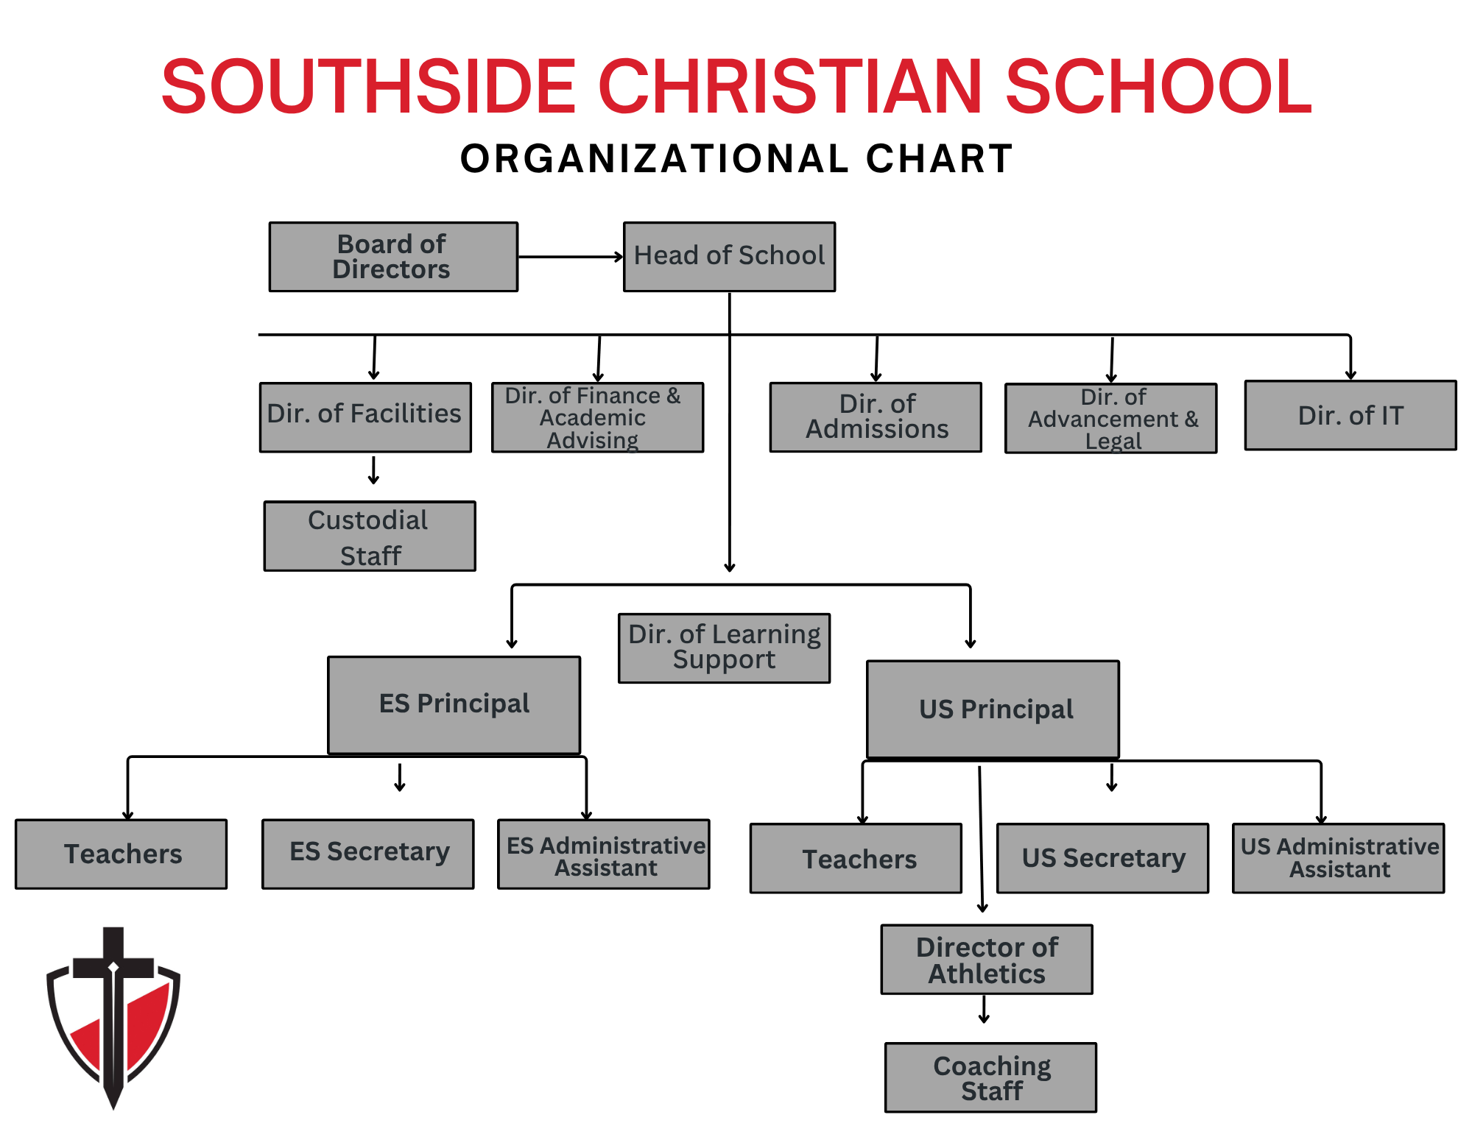
SCS Organizational Structure

Contacting the School
Office Phone Number (919) 585-6742
Website: www.scswarriors.com

Administration
Mr. Zach Zebro, Head of School zzebro@scswarriors.com
Mrs. Kellie Nothstine, Director of Advancement and Legal knothstine@scswarriors.com
Mrs. Emily Holley, Director of Admissions eholley@scswarriors.com
Mr. John Larry, Athletic Director jlarry@scswarriors.com
Mrs. Cindy Love, Business Manager clove@scswarriors.com

Elementary School
Mrs. Jessica Knott, Elementary Principal jknott@scswarriors.com
Mrs. Jennifer Smith, ES Administrative Assistant jsmith@scswarriors.com
Mrs. Christa Honeycutt, ES Secretary choneycutt@scswarriors.com

Upper School
Mr. Andrew Coffman, US Principal acoffman@scswarriors.com
Mrs.Emily Cain, US Administrative Assistant ecain@scswarriors.com
Mrs. Molly Corl, US Secretary mcorl@scswarriors.com

ACCREDITATION
Southside Christian School is fully accredited grades K4-12 by the Association of Christian Schools International (ACSI) and Cognia. Southside Christian School was initially accredited in 2013 and re-accredited for an additional five years in 2018 update
Due to our accreditation, SCS is exempt from licensure by the State of North Carolina.

PERMISSION
Your child’s image as captured during school activities may be used in promotional material by SCS, including social media accounts (sports Instagram page and Facebook). Please inform SCS via email by contacting choneycutt@scswarriors.com (ES) or mcorl@scswarriors.com (US) no later than the end of August if you do not grant permission for your child to be included in photos or videos depicting chapel, sports, classroom interactions, school plays, etc. for promotional use by SCS.

SEVERABILITY CLAUSE
If any provision, or portion thereof, of this agreement is held to be invalid or unenforceable by any court or arbitrator of competent jurisdiction, such provision, or portion thereof, shall be modified or deleted in such a manner so as to make this agreement, as modified, legal and enforceable under applicable laws and shall not affect the validity of the other clauses or portions thereof of this agreement.

CLOSED CAMPUS
SCS is a closed campus. This means students are not free to come and go as they please and that all visitors must check in with the front office.

ADMISSIONS

Admission Policy
- Southside Christian School admits students of any race, color, national and ethnic origin to all rights, privileges, programs and activities generally accepted or made available to students at the school.
- All incoming students to SCS are considered to be on probation during their first quarter at SCS.

Spiritual Requirements
- The parent with primary legal and physical custody must desire a Christian education for their children and willingly support the school’s spiritual goals and objectives.
- The parent with primary legal and physical custody must be a professing believer in Jesus Christ as their Savior and be an active member in a church of like-faith.
- Parents may be required to provide a Pastor’s Reference Form every few years for re enrollment.
- High school students may be asked to submit a pastoral reference for admission to SCS and at reenrollment.

Academic Requirements
Southside Christian School admits students that we feel will be successful in our academic program. We assess this using previous grades, teachers recommendations, standardized test scores, and SCS entrance exam scores.
New students must meet the following criteria to be enrolled in the next successive grade level:
- Have documentation showing successful completion of the previous grade by a demonstrated proficiency in the core areas of reading, math, English, science, and social studies (history and/or geography) within the previous grade.
- High school students must show proficiency in all high school years they have attended in previous schools.
- Recognizing that many public schools (and some home schools) do not use letter grades (A-F) or percentages to indicate academic proficiency in the elementary grades, a mark of satisfactory in core subjects on the student’s transcript report card will be acceptable.
- The result of any in-school testing will be combined with a new student’s report card and any previous standardized testing scores to determine the best grade level for that student to enter at Southside Christian School. Students will be tested by SCS unless enough documentation can be provided to ensure students are on grade level.

Behavioral Requirements
- Students must be in good standing with their current school (attendance, discipline record, etc.)
- Students with a history of self-destructive behaviors (drugs, alcohol, violent behavior, etc.) must not have any suspensions for at least a full semester in another school program prior to being considered for admissions to SCS.
- Students who have been expelled or have multiple suspensions from any school must complete a full semester in another school program (homeschool does not qualify) and provide documentation of completed counseling (certified counselor) before being considered for admission to SCS.
- All educational and pastoral references will be considered.
- Students must have a spirit of cooperation and effort towards success in SCS.
- All preschool and kindergarten students entering SCS must be fully potty trained.
- Children must turn 4 prior to August 31st prior to entering K4 and 5 prior to August 31st prior to entering K5.
- The first quarter is considered a probationary period for all new students.

Lifestyle Policy
- SCS is a religious, non-profit Christian school representing Jesus Christ throughout Johnston and surrounding counties of the Raleigh region of North Carolina. SCS requires all employees and at least one parent to be a born-again Christian, living their lives as Christian role models (Rom. 10:9-10; 1 Tim. 4:12; Luke 6:40). Employees and parents will conduct themselves in a way that will not raise questions regarding their Christian testimonies.
- A Christian lifestyle should reflect the biblical perspective of integrity and appropriate personal and family relationships, business conduct and moral behavior. A parent is expected to demonstrate a teachable spirit, an ability to share love for others, a willingness to live contentedly under authority and a commitment to follow the Matthew 18 principle when an issue arises with employees or management.
- Therefore, the parties agree that any claim or dispute shall be settled by biblically-based mediation. If resolution of the dispute and reconciliation do not result from mediation, the matter shall then be submitted to a panel of three independent and objective arbitrators for binding arbitration. Each party to the agreement shall have the right to select one arbitrator (unless the parties mutually agree to the use of only one arbitrator). The two arbitrators selected by the parties shall jointly select the neutral, third arbitrator. If there is an impasse in the selection of the third arbitrator, the Institute for Christian Conciliation division of Peacemaker Ministries of Billings, Montana [(406) 256-1583] shall be asked to provide the name of a qualified person who will serve in that capacity. The mediation and arbitration process shall be conducted in accordance with the "Rules of Procedure for Christian Conciliation" contained in the Peacemaker Ministries booklet.

Guidelines for Christian ConciliationThe parties agree that these methods shall be the sole remedy for any controversy or claim arising out of the employment relationship, parent/student relationship, or this agreement and expressly waive their right to file a lawsuit against one another in any civil court for such disputes, except to enforce a legally binding arbitration decision. A copy of the booklet Guidelines for Christian Conciliation is available, upon request.

- The SCS Statement of Faith expects parents to maintain a lifestyle based on biblical standards of moral conduct. (Rom. 1:21-27; 1 Cor. 6:9-20).
- SCS believes that biblical marriage is limited to a covenant relationship between a man and a woman.
- SCS employees and parents will maintain a lifestyle based on biblical standards of conduct. Failure to do so may result in a reprimand or, in some cases, dismissal from employment. In the case of parents not living a lifestyle based on biblical standards of conduct, that may result in a family being asked to not continue partnership with SCS in the education of their children.
- It is the goal of SCS that each employee and parent will have a lifestyle where “…He [Christ] might have the preeminence.” Col. 1:18. “... He [Christ] might be preeminent.

Continuous Enrollment
The Continuous Enrollment Policy aims to provide a seamless and efficient enrollment process, ensuring stability and commitment within the school community. This policy applies to all students enrolled in Southside Christian School.

Continuous Enrollment Requirement
- Students are automatically re-enrolled each academic year unless a formal opt-out request is submitted by the designated deadline.
- This policy eliminates the need for annual re-enrollment paperwork, simplifying the process for families and the administration.

Opt-Out Process
- Families wishing to withdraw their child must complete the Withdrawal Form by February 5, 2027. Families completing the form by the deadline will not be charged the enrollment fee for the upcoming academic year.
- Failure to submit the Withdrawal Form by the deadline will result in automatic re-enrollment for the next academic year.

Financial Obligations
- Continuous enrollment ensures that families are aware of and can plan for financial obligations, including tuition and fees, for the upcoming academic year.

Communication and Support
- SCS will publish the upcoming school year’s tuition and fees document, enrollment fee, and other information. All of this will be communicated to families so an informed decision can be made about returning to SCS.
- Reminders will also be sent to current families about notifying SCS by the February 5 deadline about not returning.
- A pastor’s reference may be required for reenrollment as a student enters grades 3rd, 6th and 9th.
- Southside Christian School reserves the right to not reenroll a student based on family testimony, parent’s or student’s inability to comply with any school policy, and/or outstanding tuition payments.

Learning Support Program (LSP)
- Southside Christian School desires to serve students with learning difficulties. However, we understand our limitations as a small ministry and realize we cannot provide services needed for every need level. Test scores, current IEPs and 504 Plans will be reviewed to determine if we are capable of meeting a student’s needs prior to acceptance. Failure to submit prior testing/special education records upon admission may result in immediate student dismissal. SCS will only admit students we are capable of serving.
- If a parent or teacher recognizes a possible learning difficulty, the administration should be notified. The LSP Team will work with the teacher and parent to determine appropriate next steps including recommendations for testing and accommodations/modifications in the classroom as appropriate. Additional fees may apply.
- Modifications are indicated on the report card along with a brief explanation.

TUITION COLLECTION

Automatic Draft
- All payments are expected to be made through the automatic draft system (ACH) with FACTS.
- Only families who elect to pay in full will be given the option to not set up ACH withdrawal to FACTS.
- Families who pay in full by check will still need a FACTS account for incidentals.
- Families choosing to pay incidentals by check will incur additional fees.
- In May, the first payment for the upcoming school year is due. A payment schedule is available on the website.
- A fee of $25 is incurred for changing ACH information during the school year.

Delinquent Account
- There is an insufficient fund charge of $30 per student for funds not available for a scheduled ACH and for any returned check.
- Prior to your account becoming delinquent, please schedule a meeting with the Head of School to make arrangements for payment and avoid disruption to your child’s education.
- SCS reserves the right to withhold final report cards, transcripts, student records, and/or diplomas until the account is brought current.
- SCS reserves the right to withhold reenrollment if an account is delinquent.
- Students with delinquent accounts may not continue to charge lunches to their accounts.

Tuition and Fees
All tuition and fees are included in the annual information available on the school website.

Tuition Obligation and Withdrawal Fee
- Students are considered enrolled for the entire school year; therefore, budgets and teacher contracts are set accordingly. The early withdrawal of a student creates an opening which Southside Christian School may not be able to fill with a new student.
- After acceptance of admittance to SCS between enrollment and July 1st of the current year, there is no withdrawal fee. For withdrawal after April 1st there is a $500 withdrawal fee. If withdrawal after the first day of school the family is responsible for the $500 withdrawal fee per child and tuition (prorated by the marking period). Admissions application/registration/reenrollment/resource fees are not refundable for any reason.
- Refunds are for tuition only, and will be made on accounts that are paid beyond the current month. Official transcripts, report cards, and records cannot be released or sent to other schools if an outstanding balance remains at Southside Christian School.

Tuition Payment Options
- Annual Payment - 2% tuition discount per year (resource fees not included in discount) if paid in full by May 1st. If paying in full, the resource fee is due at the time of reenrollment.
- 12 Month Payment Plan - First payment made in May; subsequent payments made monthly from June through April. When setting up their FACTS account, parents may choose to have their tuition draft on the 5th or the 20th of the month.

ACADEMIC GUIDELINES

Achievement Test
- Southside Christian School uses NWEA MAP Growth to assess student progress. These tests are nationally normed achievement tests.
- NWEA MAP Growth is administered as scheduled; please see the school calendar for specific testing dates.

Bible Text
The English Standard Version (www.esv.org) of the Bible is the primary translation used in the classroom for memory work and for tests. Longer passages will be memorized in the ESV. Other versions may be used for reference purposes. Students should bring their own Bibles to school. We also recognize the value of other translations used by many school families.

Grading Guidelines
Report cards for all students will be emailed at the end of each marking period.

Elementary enrichments will utilize the following grade scale:
- E Excellent
- S Satisfactory
- N Needs Improvement U Unsatisfactory

All grades K4-12 use number grades. use number grades on report cards, except for elementary enrichments as mentioned above.
- A 90 – 100
- B 80 – 89
- C 70 – 79
- D 60 – 69
- F Below 60

Homework Philosophy and Guidelines
- Students may have homework in all of their classes on a regular basis.
- The assignments given as homework are designed to develop initiative, responsibility and self-learning.
- Homework provides an opportunity to practice and apply concepts learned within the classroom.
- Average homework assignments per night are:
- Kindergarten-2nd Grade = 20 minutes
  - Grades 3th-5th = 40 minutes
  - Grades 6th-12th = Ten minutes per grade level (i.e.: 6th gr = 60 min, 7th gr = 70 min, etc.)
  - AP/Honors or other advanced classes may require an additional homework load.
- Times will vary if the child does not make efficient use of time or has not mastered a specific skill. For example, a student who has mastered his/her math families will complete his/her assignment more quickly than a student who is struggling in that area.
- Parents are encouraged to send a note to the teacher if their child is habitually taking longer than recommended to complete the homework assignments.

Honors and Awards
- Elementary school students who finish the year with all A’s in core subjects will receive the A Honor Roll; core subjects do not include penmanship.
- Upper school students that finish the year with all As for their final grade in each class will receive the A Honor Roll. Upper school students that finish the year with all As and Bs for their final grade in each class will receive the A/B Honor Roll.
- Elementary Perfect Attendance: Awarded at the end of the year for students who have not missed any days or have not had three or more unexcused tardies or early dismissals in a marking period.

Parent/Teacher Conferences
We believe that students benefit from the coordinated efforts of the Parent-Teacher team. Communication is paramount to students’ success in and out of the classroom.
- A Parent/Teacher conference will be offered for all elementary parents at the end of the first grading period.
- Parents of upper school students may schedule a conference as needed throughout the year.
- Parents may email their child’s teacher any time to discuss concerns or questions they may have.
- Conferences may be scheduled via email to the student’s teacher.

Academic Progress, Intervention, and Retention Policy
SCS's goal is to partner with families to support each student’s academic growth. The following outlines how we monitor progress, communicate concerns, and make decisions regarding promotion and retention.
SCS students successfully completing the requirements for their grade level will be promoted to the next successive grade

Ongoing Monitoring & Communication
- Quarter 1 (First Nine Weeks):
Parent-teacher conferences are required for any student demonstrating academic or behavioral concerns.
- Quarter 2 (Mid-Year):
  - Prior to Quarter 2 Report Cards, the school will identify students considered “at risk.”
  - At Risk is defined as having an F or more than 2 Ds in core subjects.
  - Parents of at-risk students will receive formal written notification from the school.
  - If additional academic data is needed, assessments such as IXL diagnostics may be used.
- Quarter 3 (Third Nine Weeks):
A Retention Review Team will evaluate at-risk students using:
  - Standardized and classroom test data
  - Report cards and teacher comments
  - Attendance records
- Parents will receive an updated letter communicating their child’s status.
- Quarter 4 (Final Nine Weeks):
  - Final determinations regarding promotion or retention for the upcoming school year will be made by progress reports of quarter 4.
  - Parents will receive official written notification from the school
Retention criteria may be initiated at any point in the year that a student becomes At Risk.
. ● Students failing one or more classes may be retained or with administrative approval be required to take a summer course for credit recovery
- Students identified as needing support with promotion may be required to complete IXL coursework during the summer to strengthen foundational skills as part of their promotion.
- The school will communicate expectations and monitoring procedures for summer work.
- Failure to complete may result in retention.

GENERAL SCHOOL POLICIES

Asbestos Notice
The US Environmental Protection Agency’s (EPA) Asbestos Hazard Emergency Response Act (AHERA) requires all schools to inspect building materials for the presence of asbestos. AHERA excludes schools from the inspection requirement if the school was constructed after October 12, 1988, and has a signed statement from the architect or project engineer responsible for constructing the school stating that no
asbestos-containing building materials were specified for use in the construction of the school.
- Our school has been provided such a statement, and is, therefore, exempt from the requirement to conduct an asbestos inspection.
- The EPA requires us to annually notify you that we are aware of the AHERA regulation, and that we are in compliance. The management plan is available for your review at any time during normal school hours. (Monday-Friday, 8:30 a.m. – 3:00 p.m.)

Attendance

North Carolina’s Compulsory Attendance Law (NC GS 115C-378) requires that parents have their school aged children continuously in school for a period equal to the time which the public school is in session. SCS believes that learning happens best when students are in class. Please make every effort to ensure your child is in class and inform the school when absences occur.

Elementary

- Each teacher will keep an attendance record for each student at the start of each school day.
- If a student is absent, the teacher will prepare homework (worksheets, instructions, books, etc.) to be sent home the day following an absence.
- If a student will miss consecutive days, the teacher will prepare work to be ready for pick up as arranged with the parents through the front office.
- Students who fail to complete classwork or testing during a given grading period will receive an “M” (missing) until the work is completed within the makeup window.
- Administration requests all absences be documented
- More than five absences in a semester will require professional documentation.
  - The SCS Administration reserves the right to verify the information with the professional.
  - Consistent attendance is required for academic progress.
  - Clear communication between home and school is essential. Parents should notify the school promptly regarding absences and partner with teachers to support student success

  - 5 Absences in a semester: Attendance letter of notice
  - 10 Absences in a semester: Attendance conference will be required
  - 15+ Absences in a semester: May result in academic review, retention consideration, or administrative action, including withdrawal.
  - 3 Tardies = 1 absence

Upper School
- US attendance is taken during each class (a student will be considered absent if he/she misses one half or more of that class period). It is expected that teachers will keep attendance for their class in RenWeb.
- Upper School teachers are responsible to contact the front office if a student does not report to class but classmates say they are at school that day.
- If a student will miss consecutive days, the teacher will prepare work to be ready for pick up as arranged with the parents through the front office.
- Students that have had an extended period of absence right before the end of a grading period will receive an “I” (incomplete) until the classwork or testing is completed.
- Students must be in school for at least three continuous hours to be eligible to participate in an extracurricular activity, including athletics.
- MS students missing more than 10 periods of a class per semester or 20 periods a year may not receive credit for the class. Excessive absences may require that class/credit remediation be completed, at a cost of $10 per hour, in order to receive a passing grade for the class. Continual absences may result in the withdrawal of the student from SCS.
- HS students missing 5 blocks of class per semester or 10 blocks a year (Friday classes count as .5 of a block) may not receive credit for the class. Excessive absences may require that class/credit remediation be completed, at a cost of $10 per hour, in order to receive a passing grade for the class. Continual absences may result in the withdrawal of the student from SCS.

Tardiness
- Tardies disrupt the classroom. To be counted “on time,” elementary students must be seated and ready for school at 8:05 a.m. Students will be counted tardy at 8:05 a.m. Parents must sign in at the front office.
- Upper school students must be present and in their seats at the start of each class period.
- Three tardies are considered one absence. Please refer back to the attendance policy concerning absences.
- If a student arrives at school late and misses a test, they should make up the test during lunch or after school to avoid a late penalty.
- When a student leaves early, it is counted the same as a tardy.
- Leaving early three times within one marking period will count as an absence.
- At the upper school, the third tardy and each additional tardy will be a demerit.

Sibling Care
Families with students in both Elementary and Upper School now have two options:
- Pick up your elementary student(s) during elementary dismissal and then re-enter the car line to pick up your upper school student(s).
- Enroll your elementary student(s) in After Care until your upper school student is dismissed.
- To better support families who only need care for a short period of time, SCS has added a third After Care pricing tier designed specifically for brief afternoon use.

Before and After School Care Program
Before School Care (BSC)
- Before school care is provided on a drop-in basis for all students. Parents may drop their elementary child off beginning at 7:00 a.m.
- Students must report to the before care worker to be supervised until they are released to their classroom.
- The cost for before care is $5 per child per day.
- Parents will receive an invoice through our FACTS system for services used.
- When SCS has a delayed opening, BSC will operate following the same delay. (For example, when SCS has a 2 hour delay, BSC will operate on a 2 hour delay.)

After School Care (AFC)
- Elementary after-school care hours are 3:00 p.m. to 6:00 p.m. while SCS is in session.
- Upper school after-school care hours are 3:05 p.m. until 6:00 p.m.
- SCS will no longer offer sibling care for elementary s
- There will be no ASC on early release days or inclement weather days.
- Payments will be collected through FACTS on the specified date each month.
- Registration and Enrollment: Registration forms and a $50 per student non-refundable ASC Program registration fee must be completed for a student to be enrolled in the SCS ASC Program.
- Fees: For pick-up before 3:30 p.m. the fee is $20 per student per week, for pick-up before 4:00 p.m., the fee is $45 per student per week. For pick-up after 4:00 p.m., the fee is $80 per student per week.
- Drop-in care is available after school as part of the ASC Program.
  - Registration forms/fee required after three times of usage.
  - A $10 per day fee will be charged for pick up before 3:30 p.m.
  - A $15 per day fee will be charged for pick up before 4:00 p.m.
  - A $30 per day fee will be charged for pick up after 4:00 p.m.
- Students remaining on campus after carpool will go to after school care. Drop-in fees will apply.
- Late Fee: There will be a late fee billed in $1 per child per minute for pick-up after 6:00 p.m.
- Student Release: All children must be signed out daily by the parent or designee as indicated on your registration form. If someone not listed on your registration form needs to pick up your child, we must have written permission from you along with photo identification from the person picking up your child.
- Snacks and drinks will not be provided. Children may bring a snack and a drink from home if desired.
- Homework: Time will be available for students to do homework during each session. The AFC worker is not responsible for homework quality or tutoring. Parents are responsible to see that homework is completed.

Care of Students
In order to ensure the safety and care of its students, Southside Christian School adheres strictly to the law in regards to reporting to Johnston County Department of Social Services all claims of child abuse brought to our attention.

CAR LINE

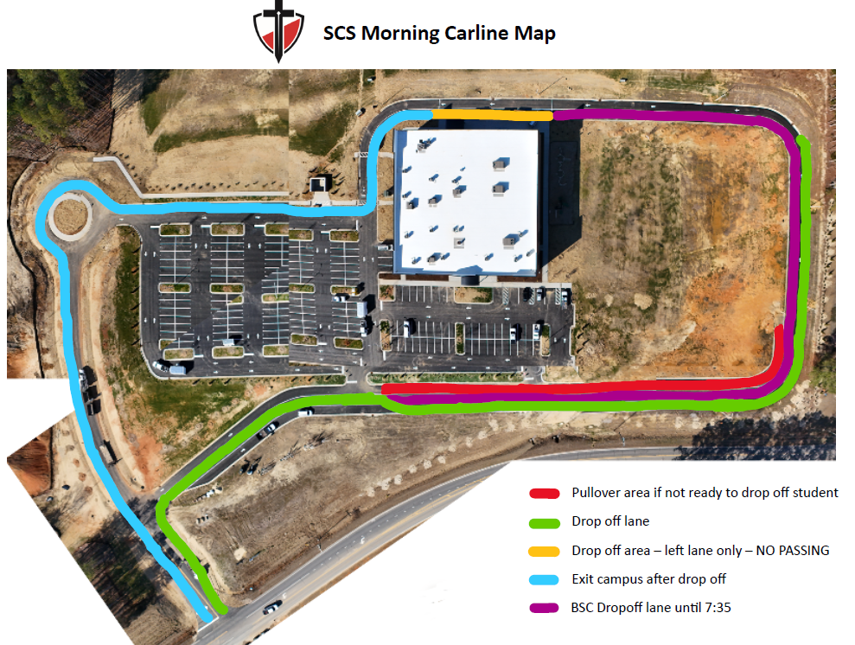

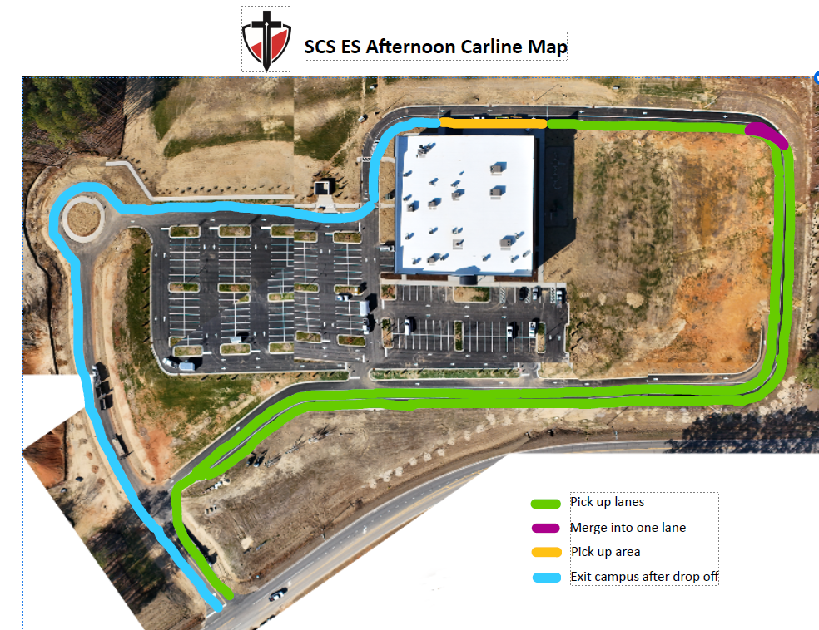

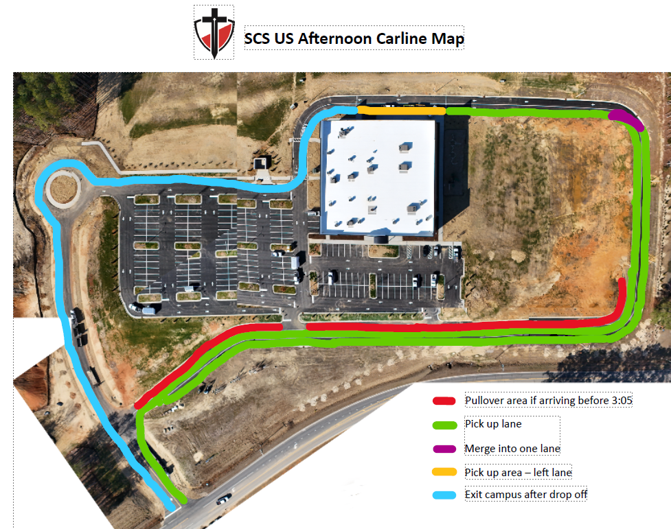

Cell Phones and Other Electronic Devices
- Students are not permitted to use mobile devices (including but not limited to cell phones, smartwatches, etc.) at their leisure while on school property.
- Students remaining at SCS after school for school activities are required to obtain permission from the teacher, coach or extended care personnel prior to using their device.
- Students are not permitted to video or audio record at any time on school property unless it is authorized by a teacher as part of a class project. Violation of this standard will result in the student losing the privilege of bringing electronic devices on campus and demerits will be given in the US.
- Cell phones are permitted on campus and must remain out of sight in the student locker unless approved by teachers for educational use.
- Cell phones must be turned off rather than in silent or vibrate mode.
- Smartwatches may be worn in high school, but must have notifications turned off and be removed during assessments. Elementary and MS students may not wear smart watches.
- At any time, teachers may instruct students to remove a watch and put it away.
- Cell phones may not be used during the school day to make or receive phone calls or text messages without teacher permission and supervision.
- Upper School students who need to access the internet for research or classwork during the school day may use SCS devices.
  - The teacher will check out computer carts when needed in middle school.
  - SCS has filtration devices in place to control the internet access points that students will use with their laptops/tablets.
  - Students in grades 8-12 may bring their own device. However, personal hotspot devices and usage is not permitted.
- All student phone calls, incoming or outgoing, should be made through the school office unless otherwise instructed by school administration.
- Please know that you may call the office and leave a message at any time if you need to get in touch with your child.
- Students may call parents in the case of an emergency from the office telephone or personal cell phone with permission.
- Administration and staff members will ask the student for their cell phone/Smartwatch if it is used during school hours.
  - SCS administration will notify the parent.
  - SCS administration will return the phone to the parent at the end of the day.
  - SCS administration will issue consequences.

Discipline
Discipline involves training a child so that he can take moral responsibility for his own choices. Discipline is sometimes required as a consequence for making poor choices. However, our emphasis is on positive instruction and practice in proper behavior. We want the child to be guided by love of virtue, not fear of reproof. Our goal is having each student accept Jesus Christ as his Lord and Savior and surrender to His Lordship; at that point, the child can learn to “walk in the Spirit,” and the child’s relationship with God becomes his moral compass.

Philosophy of Discipline
- Hebrews 13:17 makes it clear that it is profitable for children to “obey those that have rule over them”. Jesus says that we are His friends if we obey Him (John 15:14). Obedience is responding with the right attitude, immediately and completely. The goal of all corrective action is the restoration of the student’s right standing with a peer, an authority and/or the Lord. We know that all children struggle with self-will; that is man’s condition.
- The following is a list of many of the scriptures that helped us formulate the approach we take to discipline at SCS: Eph. 6:1-3, John 1:5, Deuteronomy 10:12-13, Galatians 3:24-25; 5:16, Matthew 22:37-40, Philippians 2:3-4, Proverbs 22:6, and 2 Timothy 3:16-17.

Methods of Training
- There are a number of venues we use to teach students the right ways to go. We believe that unless children are trained, they cannot fairly be expected to obey the school’s rules and guidelines.
- We use instruction and practice in proper behavior, positive reinforcement, natural consequences, parent conferences, after school detentions (ASD), in-school-suspension (ISS), out-of-school suspension (OSS), loss of privilege to participate in athletics (eligibility) and if necessary, asking the parent to withdraw the student.

SCS Student Expectations

Examples of Misbehavior
- Not wanting to listen or learn
- Not following the teacher’s directions

Supporting Scripture
Obey them that have the rule over you, and submit yourselves: for they watch for your souls, as they that must give account, that they may do it with joy, and not with grief: for that is unprofitable for you. Hebrews 13:17

Respect for Others

Examples of Misbehavior
- Abusing someone else’s property
- Bothering another student
- Excessive loudness and disrespect

Supporting Scriptures
Thou shalt love thy neighbor as thyself.” Matthew 22:39, Let nothing be done through strife or vainglory; but in lowliness of mind let each esteem others better than themselves.” Philippians 2:3

Diligence to Duty

Examples of Misbehavior

- Not doing homework
- Not having books or supplies ready when class begins
- Not in dress code
- Talking without permission

Supporting Scripture
In whatever you do in word or deed, do all in the name of the Lord Jesus, giving thanks through Him to God the Father.” Colossians 3:17, Whether therefore ye eat, or drink, or whatsoever ye do, do all to the glory of God. 1 Corinthians 10:31

Exercise Godly Character

Examples of Misbehavior
- Inappropriate language
- Fighting
- Lack of reverence in chapel or school
- Lying
- Stealing

Supporting Scriptures
Thou shalt love the Lord, thy God with all thy heart, and with all thy soul, and with all thy mind… Thou shalt love thy neighbor as thyself.” Matthew 22:37-38, Let no corrupt communication proceed out of thy mouth. Ephesians 4:29

Guard God’s Property

Examples of Misbehavior
- Destruction of school property
- Using more than is needed of items regardless of cost
- Writing in books, walls, desks

Supporting Scripture
He that is faithful in that which is least is faithful also in much; and he that is unjust in the least is unjust also in much. If therefore ye have not been faithful in the unrighteous mammon (money, property), who will commit to your trust the true riches (spiritual things)?” Luke 16:10-11

Additional US Student Expectations
These expectations take into consideration that US students understand that each student is an important part of the whole of our student body. As we train in Godly living, it is hoped that each student will continue to grow in their understanding of how they should conduct themselves in any given situation.
- We anticipate that students will treat each other the way they would like to be treated.
- Students are expected to take personal responsibility for their own behavior and property. It is expected that if an incident occurs, either because of immaturity or foolishness, and there is damage to property belonging to Southside Christian School, the student will report it to the administration and that he, or his parents, would assume liability for damages incurred.
- Students are expected to come to school each day completely dressed in the appropriate school uniform. It is further expected that each student will be clean and neat, having taken care of routine personal hygiene.
- It is expected that students who drive a vehicle to school will obey safety rules in the parking lot and follow traffic patterns. Having a car on campus is a privilege and students are asked to keep their music down low as a courtesy. Loitering in cars during school is not allowed. Violation of this policy can result in the loss of driving privileges on campus.

Elementary School Discipline
- SCS elementary classes utilize a classroom management system.
- ES Teachers will communicate with parents when there is a pattern of disruptive behavior.
- Discipline concerns will be recorded in RenWeb as a behavior alert.
- The ES Principal will be involved in ES student discipline when necessary.
- ES discipline may include: alternative recess time, time in a peer classroom, silent lunch, calls home, and in unusual cases an out-of-school suspension or request to withdraw the student.

US Detention/Suspension System

The following list is compiled for your benefit in achieving a better understanding of our disciplinary system. It is not meant to be an exhaustive list. The administration of Southside Christian School reserves the right to take any and all disciplinary measures that it deems appropriate as it relates to acts of misconduct on the part of our students. Demerits, except when counted for expulsion, will reset at the end of each semester. Offenses both on and off school grounds are enforceable by SCS inasmuch as it impacts the SCS community as determined by the school administration.

Cumulative Demerit Penalties
Every 5 demerits equals an after-school detention

25 demerits - Parent Meeting with Principal
30 demerits - 1 Day out of school Suspension
30 demerits - Probationary Status
35 demerits - Out of school suspension (# of days determined by administration)
35 demerits - Probationary Status
40 demerits - Administrative Student Discipline Review
40 demerits - Removal from extracurricular activities
45 demerits - Withdrawal Review

Probationary Status - A student who receives more than 30 demerits during a school year will go on probation. Probationary status means the loss of extracurricular activities for a period of time. The first occurrence of probationary status is 2 weeks, the second is one month. Probationary status requires a meeting with parents and an agreement to the probationary requirements. Successful completion of probation will be indicated by no additional demerits earned during the probationary period.

Detention Offenses
One Demerit Offenses
These are essentially written warnings. Five demerits will result in a detention. For other offenses, the student may be referred to the administration for detention or suspension.
- Horseplay (defined as having no malicious intent)
- Minor class disruption (talking, goofing off, or any other actions that distract from learning)
- No textbook in class
- Driving/parking violation
- Eating in the classrooms
- Regularly forgetting to turn cell phone off
- Minor dress code violations (Things that you would not be sent home for or have new clothes brought to you in order to change.)
- Using technology for non-educational purposes during the school day
- Using headphones, earbuds, etc. unless directed by a teacher as required in the computer lab for foreign language classes or as part of an LSP requirement
- Tardy to a regular class (not school)

After School Detention Offenses
(each of these offenses equal up to 5 demerits)
Every 5 demerits up to 20 demerits, the student will be assigned an after-school detention. The first 5 detentions will be served after school from 3:00 to 4:00 p.m. and a $10 fee will be assessed to defray the cost of hiring a detention supervisor, who is appointed by the administrator. Detentions will be served on Tuesdays and Thursdays. Cell phones and headphones will be kept in the office while serving the detention.
- Loitering on any school property before or after school
- Inappropriate public displays of affection such as lingering hugs, hand holding, touching that demonstrates an increased familiarity with the other person, etc. Inappropriate public displays of affection can occur between students of the opposite sex as well as students of the same sex. The school will not distinguish between displays of affection that are truly affection based and those that are done out of jest.
- Being involved in unsafe activities on school property
- Repeated minor dress code violations (beginning on the third offense)
- Unauthorized absence from class while on school premises, for example showing up for class 10 minutes late because a student talked to this or that person without getting permission from their teacher.
- Major dress code violations (Things that you would be sent home for, or have new clothes brought to you in order to change.)
- Coarse jesting, not blatantly vulgar but could be taken in an inappropriate manner
- Repeated cell phone violations (beginning with the 3rd offense)

More Severe Detention Offenses
(Offenses normally run between 5 and 20 demerits)
- Mutilation, destruction of property, or activity that may result in mutilation or destruction of property (The student may also be required to pay for damages.)
- Use of inappropriate language, such as obscenities, vulgarity, or profanity (i.e. traditional or new curse words, taking the Lord’s name in vain, etc.)
- Bullying, rough housing, or other forms of rowdy behavior, including games designed to inflict pain (for example, any game that involves slapping or hitting each other)
- Violation of computer/Internet policies/Student Personal Technology policy
- Direct disobedience
- Disrespect to those in authority or to God’s word and teachings
- Making an audio or video recording on campus without a teacher’s permission, or posting a recording online without the permission of those in the recording. If the recording is deemed to be demeaning to or portrays a person in the recording in a negative light, an automatic expulsion conversation would occur.
- Using harassing or defamatory language as in threatening, disrespectful, or discriminatory words
- Intentionally being in an unsupervised area; avoiding faculty/staff supervision (i.e. aftercare, class, before school care)
- Lying, cheating (both copying someone else’s answers and sharing answers with someone), forgery, or other forms of intentional deception (a zero will also be given)
- Possession of a pocket knife, fireworks on school grounds or at a school sponsored activity

Plagiarism

SCS recognizes three levels of plagiarism.
- Level 1: Mostly original work, but a few ideas, phrases, or sentences are used without proper citation
- Level 2: A large portion of the paper is not the student’s work and is not cited. This can include both copying large portions of someone else’s work or ideas without proper citation.
- Level 3: Very little of the paper is the student’s work. Most of the paper consists of either directly copied or slightly modified words or ideas created by another.

The penalties for plagiarism depend on the level of plagiarism.
- Level 1: 1st Offense in middle or high school – Conference with teacher, parents informed, possible grade reduction, 2 demerits. Additional Offenses: Conference with teacher, parents informed, grade reduction, 5 demerits. After the second offense: 10 demerits.
- Level 2: 1st Offense in middle or high school – Conference with teacher, parents informed, grade reduction on the rewriting of the assignment, 5 demerits. Additional Offenses: Conference with teacher, parents informed, zero on assignment, 10 demerits
- Level 3: 1st Offense in middle school – Conference with teacher and parents, grade reduction on the rewriting of paper, possible zero on assignment, 10 demerits
  - Any offense in high school or additional offenses in middle school – zero on assignment and a minimum of 20 demerits
  - Plagiarism offenses do not reset by year or between middle school and high school. A student who is caught for plagiarism in middle school and then again in high school will receive the additional offense punishment. A second plagiarism offense, even if it is of a different level than the first offense, will receive the “additional offenses” punishment.

Suspension Guidelines

Out of School Suspension
- Any out of school suspension will be served the day after it is assigned, regardless of school events, tests, or other inconveniences.
- Students who receive 40 demerits will be removed from any sports team.

Suspension Offenses (25-35 demerits)
- Fighting (provoking a fight or failure to take reasonable steps to avoid a fight)
- Leaving the school premises without permission from the office
- Possession of weapons, chemicals, or explosives (possible expulsion). Any object used with the intent to injure or harm may be considered a weapon.
- Willful misuse of or damage to computer hardware/software
- Inappropriate use of social media

Withdrawal Review (45 demerits)
- Once a student reaches 45 demerits in a year, the administration will review that student’s discipline record to evaluate if dismissal is needed, but earning 45 demerits may result in a withdrawal.
- Dispensing or offering prescription drugs
- Misuse of over-the-counter drugs or misuse of legitimate prescription drugs may be included.
- Possession or use of tobacco products
- Possession or viewing of pornographic material
- Stealing
- Publicly and knowingly disparaging the testimony of Southside Christian School either by word or deed
- Repeated or severe bullying
- Using the internet for blasphemy, pornography, inappropriate language, or harassment
- Fighting, provoking a fight, failing to take steps to avoid a fight, or communicating threats

Automatic Withdrawal Discussion
- A student who has been withdrawn must have prior administrative approval to be on campus.
- For the safety and welfare of others, reasonable suspicion of any of the activities mentioned gives the school the right to examine lockers and any other school-owned property.
- Any illegal or criminal behavior
- Use, distribution, or possession of alcoholic beverages
- Use, distribution, or possession of illegal drugs. This includes possession or consumption of any prescription drug for which the student does not hold a valid prescription.
- Use, distribution, or possession of tobacco, e-cigarettes, or vape paraphernalia.
- Participation in sexual immorality(See footnote pg 42.)
- Possession of a firearm on school property is a felony and will result in dismissal.
- Drugs and alcohol: Southside Christian School believes that buying, selling, or other transfer of drugs and/or alcohol cannot be tolerated and will result in dismissal of the offending student or students. Consumption of drugs or alcohol is neither compatible nor permissible within the wholesome Christian environment we provide at SCS. The administration of SCS reserves the right (as per the safety of that student or any other student) to require random drug testing with the understanding that confidentiality will be maintained. If the parents and/or student refuse, then the student’s privilege to attend Southside Christian School will be revoked.
- NOTE: A student who is present when one of the above offenses takes place may be held accountable if he does not take appropriate actions. The appropriate actions include leaving immediately, encouraging the offender to report the offense, and/or reporting the offense herself/himself.

Desire for Reinstatement
- If withdrawn for a discipline reason, that student cannot come back within the same school year and must sit out one semester.
- Any readmission is contingent upon the parents and student first meeting with the school administrator to evaluate the student’s standing and attitude. If all parties are in agreement after the first meeting, the student will need to complete a restoration plan which would include regular meetings with their youth pastor/pastor.
- Based on the student’s standing, the school administrator may recommend that the student and the parent(s) write a request for readmission to the Head of School.
- If reinstatement is granted, the student will be under a probation period that is determined by the school administration based on the severity of the situation. The probation standards are determined solely upon the discretion of the administration.

Specific Limitations
As Christians, we are ambassadors of Christ, and our actions affect the body of Christ. The choices students and staff make, on and off campus, have an impact on the school’s testimony. Southside Christian School reserves the right to give consequences for defiance during on-campus or off-campus activities that bring discredit to our testimony.

The following behaviors are not permitted any time and can be grounds for immediate withdrawal: continued disrespect toward a faculty/staff/administrator member, carrying or using firearms on school property, using alcohol, drug-use, stealing, possessing or using pornography, or engaging in any form of sexual activity.
- Using tobacco, including e-cigarettes, in any form
- Drinking alcoholic beverages
- Students may not bring anything to school that directly or indirectly opposes God's standard. This includes: lewd/inappropriate music, magazines, CDs, DVDs, or accessing such on the Internet containing material that is ungodly or pornographic.
- The following items are not to be brought to school or to school functions: fireworks, lighters, matches, pets (without administrative permission), or any similar items.
- Inappropriate use of digital images taken by students that result in bringing discredit to our testimony will result in discipline of students involved and possible withdrawal from SCS.
- Students involved in fighting, extremely disruptive arguments, intimidation, and/or damaging horseplay will be escorted directly to the office.
  - Students can be suspended, either in-school or out-of-school, based on the circumstances.
  - Suspension allows for a “cooling off period,” and it gives the administration time to gather the facts and evaluate the situation.
  - Consequences will depend on the severity or nature of the incident.

Cheating
- Cheating is a very serious offense. The consequences for cheating on an assignment will include a zero on the assignment, plus possible other disciplines.
- If the individual who supplied the information to another student did so willingly, then that individual will also receive the same consequence. This policy applies to cheating on any assignment.
- Cumulative infractions may also lead to being asked to withdraw from SCS. The following are considered cheating:
- Use of a cell phone during a test or quiz.
- Using unapproved resources such as notes or cheat sheets during a quiz or test.
- Any instance of a student taking any measure to gain an unfair advantage on a test.
- Plagiarism is “taking ideas or writings from another person and offering them as your own.” The student who leads readers to believe that what they are reading is the student’s original work, when it is not, is guilty of plagiarism. Credit should always be given to the person who created the article or the idea. Be careful when you are using the Internet. Any time you use ideas or direct quotes from somebody else, you must give proper citations. This way your teacher will know ideas are yours, and you won’t be guilty of plagiarism.
- Looking at, receiving, or copying from another student or their work
- Purchasing answer keys or test booklets online

Bullying/Hazing/Racism/Harassment
- Bullying, hazing, and/or use of racism will not be tolerated in Southside Christian School and is punishable by detention and/or suspension.
- Bullying is defined as any repeated aggressive behavior displaying physical, verbal, written, or abusive treatment to negatively affect others.
- Bullying occurs when a person or group is intentionally intimidated, frightened, excluded, or hurt by a pattern of behaviors directed at them by others (Bullying in Schools – The Hidden Curriculum, Greg Griffiths, 2003).
- Bullying, hazing, and/or use of racism include but are not limited to the following behaviors:
  - Repeated name calling including but not limited to jokes, slurs, rumors, pranks, gestures
  - Posting inappropriate pictures, videos, or comments (bullying) on social media sites like Facebook, Instagram, Twitter, etc. can be devastating to students and faculty alike and as such will be dealt with according to SCS discipline policy up to, and if needed, including requesting the parents/guardians withdraw the student.
  - The following issues of bullying may become a legal matter and will require immediate notification of the Sheriff’s Office:
    - Credible threats of repeated violence made in any way, shape, or form verbally, written, or via social media
    - Forcing any sexual contact on another person
    - Students committing these acts are also subject to IMMEDIATE suspension.
    - Sexual harassment/contact, including but not limited to, sexual innuendo, touching of breasts, buttocks, or crotch, referencing or requesting sexual acts, unwanted and repeated sexual advances done by either male or female will be dealt with according to the SCS Administration.
    - No inappropriate personal contact is permitted on campus.

Prohibited Items
- Students may not possess any weapons of any kind on school property, including pocket knives, multi-use tools, guns, or anything else that could be perceived as a weapon.
- Students may not possess, display, or use any tobacco products including but not limited to electronic cigarettes at any time on school premises, including school vehicles, or while participating in school-sponsored events. This restriction applies on all school property including sporting venues that we use or lease and applies at all times, even when the student is on the school grounds as a visitor or spectator.
- Students are expected to demonstrate the Christian standards of our school outside the normal school day. In the event that a student is found to be using tobacco, e-cigarettes, drugs, alcohol, vaping or other such products outside the norm of the SCS school day or activities, SCS administration reserves the right to investigate those matters and if appropriate rescind the privilege of SCS enrollment.
- The administration reserves the right to prohibit trendy items that can become a distraction or danger to students.

Dismissal Criteria
- SCS does not allow continued misbehavior that disrupts the class.
- Once all intervention measures with the teacher and administration have been exhausted, the child may be dismissed from SCS.
- Any misbehavior that affects the well-being of the other students or teachers is deemed to be detrimental to the school.

Discipline for US Athletes and Students in Extracurricular Activities
Standard of Conduct for Off-Campus, School-Sponsored Sports Activities:
- Students who have a trend of discipline may forfeit the privilege of participating in athletics, fine arts opportunities, being a member of the homecoming court, National Honors Society, or representing the student body in SGA.
- Whether on or off campus, athletes are to demonstrate integrity in their actions and in their speech.
- All rules that apply to campus life at SCS are applicable when off campus.
- Students are not permitted in the hotel rooms of the opposite sex at any time.
- Dress code will usually be the same as during normal school activities.
- Neat jeans or knee-length shorts are permitted on some trips when approved by the administration.

DRESS CODE

All clothing must conform to the SCS Dress Code. As a school, we cannot foresee every dress code issue, the administration will address any issues that are counter to our culture as they arise.

General Rules for All Students
All dress code requirements are in effect while a student is on campus. Student dress at SCS events should be neat and appropriate.
- All clothing must be properly sized and worn modestly.
- Tops: All shirts are solid in color with no more than three buttons and must be polo style with a collar and button center placket in long or short sleeves.
- Approved colors: red, black and white
- A solid white, red, or black shirt may be worn underneath the polo shirt.
- Shirts must be neat, appropriate in size, and cover midriffs when the arms are fully extended with hands above head.
- For elementary students on a field trip a plain red polo is required and jeans may be worn.
- For upper school students a SCS PE uniform must be worn for PE. Students may now choose from SCS shorts or joggers. Order PE Uniform Here

Girls - Pre-kindergarten – Grade 12
- Pants/Capris/, Jumpers, Shorts, Skorts/Skirts/: Khaki or SOLID black made from chino, twill, or performance athletic material allowed. Pleated or flat front and cargo style are allowed. No yoga material or styles,spandex, jeggings, stretch, corduroy, or low-rise pants are allowed. No material that is transparent is allowed. Clothing that is performance athletic material is allowed and can have flexibility and stretch if it is not clingy, tight fitting, and maintains the integrity of the dress code standards. Pants and shorts that are performance athletic material must have seamed pockets and be a golf type style, true athletic shorts or pants are not permitted. Joggers are not permitted for grades 6-12th.
- All clothing must be within 2 inches above the knee or longer and be properly sized in good repair with no rips/tears/stains, etc. Black bottoms may be worn with red or white shirts only.
- Dresses with a collar are permitted in red or black. No dresses with more than 3 buttons down the front are permitted. Shorts or leggings are required under dresses and skirts for elementary girls.
- Leggings worn under dresses and skirts are permitted and should be a solid color of gray, black, or red. Patterned leggings can be worn on spirit days and Fridays under dresses and skirts.
- Socks should be appropriate and not distracting.
- Jewelry
  - Moderate age-appropriate jewelry may be worn as long as it does not distract from the learning environment or cause potential hazards.
- No more than two earrings per lobe and no more than one earring per upper ear cartilage.
- No facial piercings.
- Accessory Scarves – In general do not match the school uniform. Administration will permit female students to wear accessory scarves in times of cold weather.
Boys - Pre-kindergarten – Grade 12
- Pants, or Shorts: Khaki or solid black made from chino, twill, or performance athletic material allowed. Pleated or flat front and cargo style are allowed. No yoga material or styles,spandex, jeggings, stretch, corduroy, or low-rise pants are allowed. No material that is transparent is allowed. Clothing that is performance athletic material is allowed and can have flexibility and stretch if it is not clingy, tight fitting, and maintains the integrity of the dress code standards. Pants and shorts that are performance athletic material must have seamed pockets and be a golf type style, true athletic shorts or pants are not permitted. All clothing must be within 2 inches above the knee or longer and be properly sized in good repair with no rips/tears/stains, etc. Black bottoms may be worn with red or white shirts only. Joggers are not permitted for grades 6-12th.
- Socks should be appropriate and not distracting.
- Boys may not have piercings of any kind.
- Hairstyles
  - Boys must have hair cut so it is off the collar, above the eyes, and off the ears.
  - Sideburns are to be no longer than the middle of the ear, and when maturity warrants it, boys must be clean-shaven.
Spirit Day
Every Friday students may participate in Spirit Day. There is no fee to participate.

- T-Shirts: Students may choose to wear any appropriately fitting SCS t-shirt which is free of holes, rips, or tears.
- SCS approved sweatshirt
- Jeans must be blue, black, khaki or any shade thereof, and may be in shorts, pants or capris fashion. Any other colors are not permitted.
- Jeans must be of appropriate size and worn modestly, not oversized, sloppy or tattered.
- Low-riding jeans are not acceptable.
- Jeans may not contain holes or bleached areas.
- Dress code violations will be issued for non-compliance. Excessive offenses may result in the loss of privilege and participation of Jeans Day and refunds will not be issued.
- ES Field day will require students to wear normal uniform shorts, pants, skirts, or capris with their appropriate field day shirts. No athletic wear.

Upper School Event Dress Code
- Girls’ Dressy School Events Awards, Performances, Etc. Sleeveless as long as undergarments not visible Strapless/spaghetti straps should not be worn
- Bodice covered
- Dress length within 2-3” of the knee cap Undergarments not be visible
- Slits in dresses within 2” of knee cap

Boys’ Dressy School Events Awards, Performances, Etc.
- Dress pants or khaki pants.
- Pants should fit properly with a belt and on the hip and should not sag below the waistline. Polo or button down shirt.
- Undergarments are not to be visible. Tie or bow tie not required.
- Girls’ Formal Events – Off Campus Back open only to the waist Strapless/spaghetti straps ok
- Bodice covered
- Dress length within 2-3” of the knee cap Undergarments not be visible
- Slits in dresses within 5” of knee cap

Boys’ Formal Events – Off Campus
- A tuxedo (optional) or
- Suit jacket (optional) with matching pants or A full suit with jacket and pants
- Dress shirt (tucked in) with buttons and collar. Tie or bowtie is required.
- Undergarments are not to be visible. See-through apparel is not permitted. No ball caps.
- Pants should fit properly with a belt and on the hip and should not sag below the waistline.

PE Uniform
- Elementary students may purchase an official SCS PE uniform shirt to wear to school on PE days with their khaki uniform pants,skirts, or shorts. PE uniforms are not required for elementary students. Students not wearing an official SCS PE shirt on PE day must wear the standard SCS school uniform to school. Exception: When ES PE classes are held on Fridays, students may wear any SCS shirts.
- All students MUST wear sneakers to P.E. class.
- Upper school students are required to wear an official SCS PE uniform shirt and black shorts that have at least a 7-inch inseam for PE.
- Shorts should not be rolled up to shorten the length.
- If your child cannot wear an adult size, you may purchase alternative shorts with a 7-inch inseam or have shorts that come down to 2-inches above the knee.
- During cold weather, students may wear a sweatshirt over their PE uniform. Failure to wear a PE uniform will negatively affect the student’s grade. PE uniforms can be purchased locally at Make Life Special in downtown Clayton or online: https://scswarriorsgear.com/

Enforcement of Dress Code Guidelines – Elementary
  - First Offense - Truthful and loving counsel is given by the teacher to the parent through email, quick conference, or note.
  - Second Offense – Teacher will communicate to the parent Violation is recorded in RenWeb.
  - Third Offense – Teacher will communicate to the parent through Violation is recorded in RenWeb and a parent meeting will be scheduled with the ES Principal.
  - Repeated violations – Violations are recorded in RenWeb. A meeting with parents, ES Principal, and Head of School will be called to determine parent support for SCS policies and programs and the parents will be called to pick up the student immediately.

Dress Code Violations-Upper School
  - The administration is the final judge in deciding the appropriateness of a student’s clothing at school or at a school function.
  - Minor infrequent offenses will receive truthful and loving counsel at the teacher’s discretion.
  - At the upper school, a minor dress code violation (one that can be corrected immediately ie. removing a sweatshirt) will receive one demerit and a major dress code violation (one that cannot be corrected immediately) will receive up to 5 demerits. To correct a major dress code violation a parent may bring the student a change of clothes to bring the student into compliance or the student may change into school provided clothing for the student to meet compliance.
  - The first boy’s hair or facial hair violation will receive a write up for zero demerits. If the boy does not get a haircut after three weeknights or shave by the next day, they will receive demerits.
  - All students will stand and remove hats to show respect and support during the Pledge of Allegiance and National Anthem as part of continued enrollment at SCS.

Expected Student Classroom Conduct
Respect for self, peers, and those in authority are paramount at Southside Christian School. Respect should be taught and reinforced by the classroom teacher. SCS students should:
  - Understand the value of stopping and making eye contact with adults.
  - Speak to adults in a friendly, respectful manner.
  - Shake hands while making eye contact with adults.
  - The classroom and all of the materials in the classroom (desks, books, walls, chairs, etc.) are provisions from God and students are expected to be good stewards of His provisions.

Fundraisers
Parents may not engage in fundraising efforts without administrative approval. SCS cannot have competing fundraising efforts for events that are not school approved.

Grades - ParentsWeb
  - RenWeb’s ParentsWeb system is the primary source of communication about grades to parents.
  - Parents will receive a unique user ID and password to access their student’s grades on-line.
  - Parents are encouraged to regularly monitor student achievement, assignments, and disciplinary actions via ParentsWeb.
  - Teachers can be contacted by email through RenWeb at any time.

Grievance Guidelines
SCS Grievance Guidelines are based on Matthew 18. These guidelines are to be followed whenever there is a dispute or grievance concerning any aspect of Southside Christian School operations between two parties connected in a direct way to the school. These parties include students, parents, staff, volunteers, administration, and school board.

Classroom/Instruction
  - All concerns about the classroom must first be presented to the teacher by the parents, or if the student is mature enough, by the student himself. If the student presents the concern, a respectful demeanor is required at all times.
  - If the problem is not resolved, the parents or student may bring the concern to the Elementary Principal (if ES student) or US Principal (if US student). If the student brings the concern, he must have permission from his parents to do so.
  - If the problem is not resolved, the parents should request a meeting with the Head of School.
  - If the problem is still not resolved, the parents may request a meeting with the Southside Christian School Board.

School Operations
  - If parents or patrons have a grievance or dispute about the general operation of the school, apart from the operation of the classrooms, they should bring their concerns to the Head of School.
  - If there is still no resolution, they should request a meeting with the Southside Christian School Board.
Athletics
  - If a parent or student has a grievance or dispute about an athletic issue, their concerns should be brought first to the coach.
  - If there is no resolution, they should request a meeting with the Athletic Director.
  - If there is still no resolution, they should request a meeting with the Upper School Principal.
  - If there is still no resolution, they should request a meeting with the Head of School.
  - If there is still no resolution, they should request a meeting with the Southside Christian School Board.

Restoration
It is understood that if any disputes arise which are not covered by this policy, the Head of School and the board of directors, if needed, will decide what procedures to follow based on a parity of reasoning from those procedures established by this policy.

“If your brother sins against you, go and tell him his fault, between you and him alone. If he listens to you, you have gained your brother. But if he does not listen, take one or two others along with you, that every charge may be established by the evidence of two or three witnesses. If he refuses to listen to them, tell it to the church. And if he refuses to listen even to the church, let him be to you as a Gentile and a tax collector.” Matthew 18:15-17

Steps for resolving problems and offenses:
- Choose to give each other the “benefit of the doubt,” building relationships on a sacred trust and through the bond of Christian love.
- Apply Biblical principles of unity and positive communication.
- Deal immediately with problems when they arise, no matter how small they appear.
- Go to the source of the misunderstanding.
- Deal with problems in private with only the person(s) involved.
- Privately seek a higher authority if the problem is not resolved.
- Forgive quickly and apply mercy. Believe that God will provide total restoration in the relationship and walk in brotherly love.

Library (Elementary School)
  - Elementary students will have designated library times each month to facilitate book exchange.
  - Students are permitted to check-out books for specified amounts of time based on grade level.
  - Students may not check-out books until all previously borrowed books are returned.
  - Students are responsible for the book(s) they borrow.
  - Damaged or lost books must be replaced at the parents’ expense.
  - Donations to the SCS elementary school library are always welcome.
  - SCS reserves the right to use or not use materials based on suitability and the needs of the collection.
  - Materials not used may be returned to the donor or donated to a local ministry.
  - The SCS elementary school library does contain scientific material that may reference evolutionary theories. These books have been retained in the library because they also contain interesting facts known through observable science; however, SCS does not support evolutionary claims or references to the earth being millions/billions of years old.

Make-up Work
- When a student is absent due to illness or other reasons, they will be permitted to make up missed work upon their return.
- Elementary students will be given their make-up work upon return to school or via email from the teacher.
- If your child is going to be out of school for several days due to an illness, please contact the teacher to make arrangements to pick up your child’s work. The make-up work will be made available for pick-up the next day. Please do not stop by the school to pick-up your child’s school work unless arrangements have already been made. Please note that make-up work will not be available for pick-up the same day as the request.
- When an elementary student is going to be out of school for a planned absence, parents may request the student’s assignments ahead of time so that work can be completed during the absence. Upper school students may receive their assignments via email from the teacher or RenWeb. Completed work should be turned in upon returning to school.
In elementary school for the first day of absence, students will be given two days to complete and submit make-up work for credit. For each additional day absent, one additional day will be granted.
Example: A student who is absent for two days will have three days to complete make-up work.
- Late assignments will be penalized 10 points per day for up to 5 days. After 5 days, assignments will no longer be accepted and counted as a zero.
- In elementary, middle and high school, if a homework assignment, quiz, or test was assigned prior to the absence, the student is responsible for those assignments upon returning to school.
- Upper school students who arrive late to school missing a test, quiz, or turning in homework are expected to make them up or turn in the homework during lunch or after school, at the teacher’s discretion.
- In the event of a prolonged absence, special arrangements can be made with the teachers.

No Solicitation Policy
  - Although we recognize the value of many organizations, Southside Christian School does not allow solicitation for any clubs or organizations that are not directly associated with the school.
  - Invitations for events or activities outside of Southside Christian School may not be sent to other school families by way of your child’s homework folder, teacher, or class contact list.

School Hours
  - The elementary school drop off begins at 7:45 a.m. Pledges begin promptly at 8:00 a.m. and students are tardy at 8:05 a.m. Students are dismissed at 2:45 p.m. Please do not arrive prior to 2:40 to line up in order to avoid having cars backed up onto the road. Students will not begin lining up until 2:40 p.m.
    - Students entering the building prior to 7:45 a.m. will go to Before School Care (charges apply).
  - The middle and high school begins promptly at 8:15 a.m. and ends at 3:15 p.m. Drop off begins at 7:45 a.m.
  - Students entering the building prior to 7:40 a.m. will go to Before School Care (charges apply).
  - Students not picked up at the end of the school day will go to After School Care (charges apply).

School/Lunchtime Visitors
  - All parents and guests must use the main entrance at either campus and sign in with the secretary to receive a visitor badge that must be kept visible while on campus.
  - Visitors will not be permitted access to students until they have signed in and are cleared to enter the building.
  - Visitors other than parents and alumni require prior administrator approval to eat lunch with a student. Alumni may lose this privilege if they are not in alignment with dress code or if they are being a disruption.
  - All guests are subject to the same rules of conduct as students during their visit. Due to space limitations in the lunchroom, visitors may be required to eat lunch with their child in a classroom or outside.
  - Students should bring their own lunches to school or participate in the on-site lunch program. Politeness and civility are expected at lunchtime. Lunchtime is also reserved for quiet conversation and social interaction.
  - The school sponsors a lunch program during the week. Information on the type of lunches and cost will be sent home early in the school year and monthly thereafter. Microwaves are not available for student use.
  - Please write a note to the teacher if you plan to join your child for lunch.
  - In alignment with our student policies, visitors are expected to dress within the guidelines of the school dress code policy as it relates to length and fit of clothing.
  - No tobacco including e-cigarettes, alcohol, or disruptive behavior is permitted on school premises.

School Cancellations
  - During the initial event of inclement weather (or other school closing emergencies that impact SCS), Southside Christian School will follow Johnston County Public Schools (JCPS) regarding starting delays, early dismissals and cancellations.
  - SCS will follow JCPS for an initial inclement weather event, but may deviate from that schedule for multi-day closures.
  - If JCPS moves to remote learning due to unsafe road conditions, SCS will take an inclement weather day to allow time for assessing the safety of roads, checking the school community for Internet interruptions caused by the weather event, considering students’ accessibility to their required books, and projecting the duration of the weather event.
  - ES students will follow directions as communicated to them via Google Classroom regarding assignments.
  - Announcements will be made on the school website, local television stations , and Parents Web (text, email, and/or voicemail).
  - If SCS is unable to provide the required days of school to meet academic standards, SCS reserves the right to extend the school year or use holidays as school days as needed.

School Safety
There will be unannounced monthly fire drills, regularly scheduled tornado drills, and two lockdown drills during the year.

Snacks and Lunches
  - Please keep snacks simple and healthy.
  - ES students are not permitted to have carbonated drinks on campus.
  - Exceptions may be made for special lunches with parents or field trips.
  - There is no refrigeration available for student lunches; please plan accordingly.
  - Students will not be permitted to heat up food; please pack lunches accordingly.
  - Various lunch options will be offered throughout the week for parents who choose to order.
  - Students do not have lunch on early release days.
  - Snacking during class time is not permitted.
  - Teachers may have a special snack brought in or set aside time for a celebration where students are permitted to have snacks in the classroom.

Student Laptops
  - SCS Administration encourages Upper School students to use laptops for their educational studies.
  - Please READ carefully the SCS Technology Acceptable Use Policy 2025-2026 (in the addendum of this handbook).
  - Each family must sign a policy prior to their child using an approved computer/device.

Volunteer Policy
  - Parents may volunteer in various ways: by chaperoning field trips, assisting the teacher for special projects or parties, cleaning or helping with maintenance needs as they arise.
  - Any parent volunteering regularly at the school or who will be in an unsupervised role with students must complete a Volunteer Application and submit to a background check. Volunteer applications can be downloaded from the school website.
  - Background checks will be required for all volunteers who will be with students overnight. For the safety of the students, no person may volunteer if they have not been pre-approved through the volunteer application process.

Withdrawals
  - Parents seeking to withdraw a student during the school year will notify the administration.
  - Please do not verbalize withdrawal intentions through the student or the teacher.
  - An online withdrawal form, found under the Resources tab, on the school website must be completed.
  - Student report cards or transcripts will be released to the parents and records transferred once the account has been paid in full.

HEALTH SERVICES

Health Statements
  - All students attending Southside Christian School must have on file with the school office all medical reporting forms required by North Carolina state law.
  - Families seeking exemption from state immunization requirements must complete and submit a notarized copy of the exemption documents for the state of North Carolina.
  - If health forms are not turned in to the school by September 15th, students will not be allowed to attend class until they are turned in.

Health and Student Illness
  - Children are to be kept at home when they show any of the following symptoms: severe cold symptoms, fever (temperature exceeding 100.4), inflamed eyes (unrelated to seasonal allergies), vomiting, diarrhea, rash, ringworm, or lice.
  - It is mandatory to wait 24 hours after symptoms pass before returning your child to school.
  - Students must be lice and nit free before returning to school. Please notify the office if your child has lice. Students who have been home because of lice will be checked upon return to school and must be nit-free before returning to the classroom.

Illness or Injury at School
  - It is the goal of Southside Christian School to maintain a safe environment for students and to avoid students having to miss classwork due to an illness or injury. Every effort is made to ensure the children are playing in a kind and safe manner and are not exposed to contagions. However, there are times when students may inadvertently sustain an injury or become ill at school.
  - Southside Christian School provides CPR and First Aid training for its teachers. When a student is injured while at school, the teacher will respond in accordance with the training they have received. Parents will be notified of the injury in a manner deemed appropriate by the type of injury sustained, temperament of the student and any other mitigating factors. Notification will include one of the following: a note home, an email, a phone call, or an in-person conference. In all cases, a copy of the incident report will be sent home for the parent to sign and return.
  - If a child complains of feeling ill at school, the teacher will send the student to the school office. If there are no apparent signs of illness (rash, vomiting, diarrhea, etc.) the administration will take the child’s temperature to determine whether a fever(100.4) is present. If there is no fever present in addition to no apparent signs of illness, the administration will encourage the child to return to class. Parents may be called for consultation depending on the circumstances. If there is a fever or apparent signs of illness, parents will be called immediately. If there is a fever or other illness the school may not administer any medications including over the counter medications without a medication consent form and provided medication by the parent. SCS will not provide any medications to students.
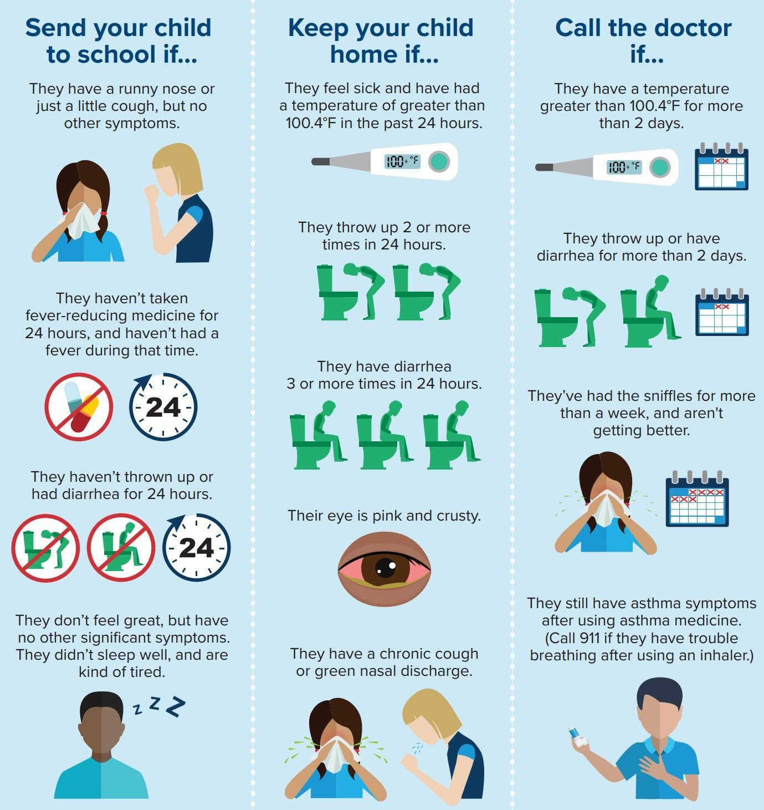
  - If we need to be aware of anything related to your child’s health or pain tolerance level, please notify your child’s teacher in writing or the school secretary for students at the upper school campus. The more knowledge we have about your child’s response to injury or illness, the better we will be able to serve the child and communicate with you should your child report a complaint.

Immunizations
  - All students are required to fulfill North Carolina requirements concerning health examinations and immunizations. Reports of compliance are submitted to the state annually as required. Parents with religious exemption(s) for their student’s immunizations must provide documentation.
  - Southside Christian School will keep a copy of all student immunizations on file.
  - Parents of ALL new students must submit a record of student immunizations before the student will be approved to attend classes at SCS.
  - In addition, NC requires SCS to provide verification of up-to-date immunizations for all Kindergarten (K5) and students entering the 7th grade.
  - The ES and US secretaries will confirm documentation is on file and accurate for all new students before admittance and will also communicate with 6th grade parents each spring about the requirement for 7th grade students.

Medications
  - The Student Medical Release Form must be completed and submitted at the beginning of each school including all medical information requested.
  - All medication taken by students should be administered by the parent(s) of the student when possible.
  - Students needing medication (prescription, over-the-counter, or supplements) during the school day must have a Medical Release Form on file with both parent and physician signature.
- No medications will be administered without physician authorization.
- This is in compliance with NC state law and there are no exceptions.
- The required Medical Release Form is available at the main office on either campus or on the SCS website.
  - Over-the-counter medications -- Acetaminophen (Tylenol), Ibuprofen (Motrin, Advil), Diphenhydramine hydrochloride (Benadryl), may be provided by families for administering at Southside Christian School. Southside will not provide any over the counter medications to students.
  - The above listed over-the-counter medications will be administered only when SCS has written parental permission on file.
  - Dosing of all medications will be consistent with the recommended dose for age as defined on package guidelines unless otherwise indicated by a physician. Faxed physician permission will be accepted.
  - All medications must remain in the possession of the school office in a locked cabinet.
  - Students are not permitted to have medication in their possession on school grounds including in lockers, lunch boxes, book bags, desks, etc. with the exception of students requiring prescription medication administered through an inhaler or Epi-Pen (see the following item).
  - No student will be permitted to administer any form (prescription or over-the-counter) of medication to himself/herself or any other student, except, students who require medication through the use of an inhaler or Epi-Pen if the following conditions have been met.
- A physician has determined that the student should carry the medical inhaler or Epi-Pen on his or her person and self-administer the medication.
- Physician’s orders need to be on file with the school office along with an Allergy Action Plan.
- Parents must complete the allergy action plan and indicate that: “the student is able to self-administer and carry the inhaler/ Epi-Pen and has been trained in its use.”
  - The elementary teacher will, in case of emergency or exceptional circumstance, administer the inhaler,
Epi-Pen, or other necessary medication in an effort to protect the student from imminent or life-threatening conditions. If the situation permits, parents will be called before any medication is administered. All parents will be immediately notified if the teacher has to administer medication due to exceptional circumstances.
  - Students with Medication Authorizations on file will be given medication according to those outlined on their medication form. If over-the-counter or other “as-needed” medication is administered, a note will be sent home to inform parents of the time and dosage.

SCHOOL-SPONSORED EVENTS

General Guidelines
  - Events organized by a SCS staff member acting in his/her official capacity
  - Events which are published on the Southside Christian School yearly calendar. Attendance at school-sponsored activities is generally limited to students who are currently enrolled at Southside Christian School. The administration may grant exceptions.
  - Timely information about school-sponsored activities will be provided to the parents.

Celebrations in the Classroom
  - Teachers or room moms will contact parents regarding holiday party schedules. Please make arrangements with the teacher to celebrate your child’s birthday at school. Do not send "private" birthday invitations to SCS students unless you plan on inviting every student in the class.
  - For student birthdays, they are allowed to bring in “non-messy foods,” such as cookies and cupcakes, to celebrate. Please provide all utensils, napkins, forks, etc.
  - Southside Christian School does not permit references to Halloween, Santa Claus, or the Easter Bunny.
  - Parents are discouraged from sending in balloons or flower bouquets for their child on special days that are celebrated by the whole school (i.e. Valentine’s Day). On holidays that are observed by the whole student body, any deliveries (i.e. balloons, flowers, etc.) made to the school for a specific child will be held in the school office and delivered to the child at dismissal time. Deliveries made to an entire class will be delivered to the class provided the teacher agrees that it will not cause undue disruption to instruction time.

Field Trips
  - Field trips provide educational opportunities for students. Attendance at school sponsored activities is generally limited to students who are currently enrolled in Southside Christian School. School field trips are an extension of the school day. Students will be counted absent for non-participation. Elementary school parents are welcome to attend any off-campus trip with their child. Parents wishing to provide transportation for class field trips must complete a Volunteer Application. Only those who have been approved as a Volunteer Driver may transport students from and to the school for school functions. Insurance and background checks will be conducted annually for anyone transporting students. If a parent wishes for another SCS adult who is a non-approved driver to transport their student to or from a school function they may sign a waiver granting consent. A new waiver must be signed for each specific occasion and date.
  - Although siblings are not permitted on field trips, nursing infants may attend to enable all parents an opportunity to enjoy the field trip with their children.

Service Projects
Students will participate in service projects throughout the school year.
  - Elementary students will participate in two local service projects.
  - Middle school students will be required to complete 10 service hours per year.
  - High school students are required to complete 20 service hours per year.
- The US Principal is responsible for scheduling and tracking US service projects/hours.
- Specific service projects may change from year to year, but the mission of reaching others with the Good News will be consistent.

UPPER SCHOOL GUIDELINES

SCS Athletic Academic Eligibility Requirements
For a detailed review of Athletic Policies please visit the Athletic Handbook.

Academic Probation
  - All incoming upper school students are admitted on a probationary basis lasting until the end of the first quarter.
  - Incoming students are expected to show evidence of a disciplined academic lifestyle, evident by consistently turning in their homework and classwork, displaying a desire to learn in the classroom by focusing during instruction, and maintaining the minimum grade requirements.
  - All students’ grades will be reviewed by administration at the end of each quarter.
- Any student with one F or 2 Ds or lower or any student consistently not completing homework assignments (missing more than 5 assignments in one quarter), may be placed on academic probation at the administration’s recommendation.
- A parent-teacher conference will be required at that time to discuss strategies for student success.
- If at the end of the following quarter a student’s grade average has not improved to where they have only one grade of 60 or below, SCS reserves the right to remove that student from our school if the Head of School sees that SCS is unable to meet the student’s academic needs.

Automobile and Student Drivers
The following guidelines are for any student drivers at Southside Christian School.

  - Students who drive an automobile to school must be 16 or older and possess a valid North Carolina driver’s license.
  - Students who must transport other students to school, except brothers and sisters, must secure permission from all parents involved.
  - Automobiles are off limits during regular school hours and are never to be used for student gathering before or after school hours.
  - Students are not allowed to go to the parking lot or to their automobile during school hours without teacher approval.
  - Proper driving etiquette and safety should be practiced at all times around the school.
  - Driving from one part of the campus to another without special permission is strictly forbidden.
  - Reckless driving, riding in another student’s automobile, on the outside of an automobile, or in the back of a pickup truck is strictly forbidden and is punishable by suspension from school.
  - Students may not drive any vehicle other than their own without written consent from their parents and the adult responsible for the other vehicle.
  - Six (6) tardies to school in one quarter may result in the loss of driving privileges for the following quarter.
  - Students will forfeit the right to drive to school if these rules are not followed.

Senior Off Campus Lunch Option
  - Seniors have the opportunity to eat lunch off campus on Tuesdays and Thursdays, if no prior event is scheduled. Students who do not wish to leave campus for lunch will remain with the rest of high school during lunch time.
  - Students must have an Off-Campus Lunch Permission Slip signed by a parent or guardian to participate.
  - Students must sign out when leaving and sign in when returning.
  - Students may not ride with or transport another student without permission from the parent of the driver and the parent of the passenger. Failing to follow this policy will result in a loss of school driving privileges.
  - Students must be back to campus and seated in the next class after lunch and will receive a lunch tardy if late.
  - After 3 lunch tardies, the off-campus lunch option for that student will be suspended for the remainder of that quarter and the following quarter.
  - Students will receive an absence for the class and a lunch tardy if 10 minutes late to the class after lunch.
  - If a student is late for class and there is a test or quiz, the student must complete the test or quiz in the remaining class time. No postponements or extra time will be allowed.
  - If a student becomes ill while off campus, a parent or guardian must call the school office and properly check the student out of school.
  - If a student fails to return back to campus and the front office is not notified, the student may be suspended.
  - The school is not liable for any accidents or injuries that occur while the student is off campus. The school is not responsible for students’ personal funds if lost or stolen.
  - The students should not bring food back for other students.

Campus Conduct

Care of Property
  - The way our property is maintained and cared for is very important as it affects the Christian testimony of its students.
  - Willful damage or destruction of school property will not be tolerated.
  - The student will be expected to pay for any damage, either willful or accidental.
  - Loitering, writing on walls, defacing of buildings, or any other act of negligence will be met with immediate disciplinary action.

Personal Behavior
  - Students are expected to conduct themselves as young ladies and gentlemen at all times.
  - Students will show respect toward all adults with specific emphasis on members of the faculty and administration.
  - Disrespect will not be tolerated under any circumstances.
  - Couples are never to be unchaperoned in the school or on the grounds. Southside Christian School is a co-educational institution operating on the premise that it is wholesome for boys and girls to develop friendships during the school year, but serious relationships are discouraged.
  - To avoid unbecoming behavior, parents are encouraged to avoid allowing students to come to school or leave school in mixed groups unless all parents involved have granted permission.
  - Outward show of affection in public, such as holding hands, having arms around one another, kissing, or any actions interpreted as sexual in nature or unbecoming to a Christian young man or woman is subject to disciplinary action up to and including suspension or withdrawal.
  - On school sponsored trips, boys and girls may not sit next to each other during travel.
  - Any unbecoming behavior, such as mentioned above, witnessed off campus and reported to the administration, will be subject to review and similar discipline.

Advanced Placement Exams
  - Students taking AP classes will have an additional cost of $150 to help cover classroom materials and the AP Exam in May.
  - SCS will arrange for AP testing.
  - Fees apply for students who are self-studying for an AP class to cover administration fees.

Counseling
  - Administration will work with the students in the areas of personal and social interests or concerns, career planning, decision-making, and post-high school planning. Included in post-high school planning are vocational-tech or college admission, job information, financial aid, and scholarship information.
  - Administration will manage the testing programs of the school, including interpretation of all test results for students and parents. Any questions regarding Achievement Testing, PSAT/NMSQT, ACT, and SAT tests may be directed to the administration.

Grade Calculation
All course grades are calculated using assessment categories. Certain assignments may be given multiple grade weights within a category. For example, announced quizzes may count as a double “daily grade” or a large project may count as a double “test grade.” Final grades will be assigned based on the following:

High School 9th – 12th grades
  - Quarter 1 20%
  - Quarter 2 20%
  - Semester Exam 10%
  - Quarter 3 20%
  - Quarter 4 20%
  - Final Exam 10%
  - All core high school classes will have a semester and final exam. High school classes that do not have semester and final exams will follow a 25% per quarter calculation.
  - All 11th and 12th grade students who have an A average for the year in a class and have missed less than 10 classes during the year, may be exempt from a written final exam in that class.

Middle School 6th – 8th grades
  - Middle school will follow the same final grade calculation as the high school for classes that have semester and final exams. The following classes will have semester and final exams:
- 6th grade Math only
- 7th grade English and Math
- 8th grade English, Math, Science, and History
  - MS classes that do not have semester and final exams will follow a 25% per Quarter calculation.

National Honor Society and National Honor Society Criteria
  - The SCS Chapter of the National Honor Society inducts students each year who demonstrate:
- Scholarship, 2) Leadership, 3) Service, and 4) Character.
  - High School students are eligible for NHS induction at the end of 10th grade if they meet the standards of the NHS and have a minimum 3.5 cumulative GPA. Starting in 2023-24, 9th grade students are also eligible to apply if they have a 4.0 cumulative GPA (All As in 9th grade)
  - Applications, including teacher and pastor recommendations, will be emailed to the student if they are rising 10th, 11th, or 12th grade students that meet the GPA requirement.
  - Students that turn in the application and recommendations by the given deadline, will have their applications reviewed by a NHS committee composed of SCS teachers, who will make the final decisions on acceptance to NHS.
  - Students in the NHS that receive multiple detentions or a suspension will need to stand before a disciplinary committee to review their continued participation in the NHS. Students may be placed on probation or removed from the NHS.

Graduation Requirements
  - In order to earn a high school diploma from Southside Christian School, the following minimum credit requirements must be met. These requirements meet or exceed the North Carolina high school graduation requirements as well as the University of North Carolina System acceptance requirements. Students must also score a 12 or higher on the American College Test (ACT). The test will be administered during the 11th grade year.
  - In order to earn an honors high school diploma from Southside Christian School, a student must have completed at least six credits from Honors, AP, or Dual Enrollment classes with a minimum unweighted GPA of 3.5.
  - Students enrolled in the SCS Learning Support program may have a reduced credit load.
  - Valedictorian and Salutatorian awards go to the top scholars in a given class. To be considered, a student must have attended SCS for their final two years of high school and have completed at least two AP classes at SCS. SCS will hand out multiple Valedictorian and Salutatorian awards in cases where students are similarly accomplished. In order to determine the recipients of this award SCS looks at the following criteria:
    - Weighted GPA
    - Unweighted GPA
    - Honors/Dual Enrollment/AP Classes
    - Core classes taken at SCS with a score of 97 or higher
    - If needed, ACT scores will be used

Graduation Minimum Credit Requirements

Subject Area | College Prep 28 Credits** | Honors Diploma Track  At least 6 Credits must be from Honors, AP, or Dual Enrollment Classes
English | 4 credits | 4 credits
Math | 4 credits | 4 credits
Science | 4 credits | 4 credits
Social Studies | 4 credits | 4 credits
Foreign Language* | 2 credits | 2 credits
Electives | 5 credits | 5 credits
Bible (waived for years that student did not attend a Christian school) | 4 credits | 4 credits
Phys Ed/Health | 1 credit | 1 credit

*Students transferring to SCS after 9th grade may be able to substitute elective credits for Foreign Language credits and may be able to earn PE/Health credit through alternative pathways.

Footnotes

Sexual Immorality
Demonstrations of romantic involvement between students on school property are forbidden. Any contact of a sexual nature that would contribute to undue familiarity will not be tolerated. This type of behavior will result in demerits, suspension, or expulsion. Boys and girls must maintain an appropriate distance at all times. Behavior should be above reproach in accordance with the ministry’s statement of faith and in recognition of Biblical commands; no immoral conduct will be tolerated. The Bible strictly forbids such conduct which includes immoral actions as well as advocating for sinful behavior. The following will not be tolerated in any form and will constitute grounds for expulsion: any actions or identifying statements concerning fornication, adultery, homosexuality, lesbianism, bisexuality, or pornography. (Gen. 2:24; Gen. 19:5, 13; Gen. 26:8-9; Lev. 18:1-30; Rom. 1:26-29; 1 Cor. 5:1; 6:9; 1 Thess. 4:1-8;
Heb. 13:4).
Definition of “immoral act”
Bodily contact, actively undertaken or passively permitted, between members of the opposite sex or members of the same sex for the purpose of satisfying sexual desires and any bodily contact that a reasonable person would understand to demonstrate a propensity or intent to engage in an immoral or homosexual act.
Definition of "identifying statement"
A statement that a student is a homosexual, bisexual, transgender, sexually active, or otherwise immoral, or words to that effect or language or behavior that a reasonable person would believe is intended to convey the statement that a student engages in or has a propensity or intent to engage in immoral, transgender, and/or homosexual acts.
Examples: “I am gay,” “I am a homosexual,” “I have a homosexual orientation,” “I am transgender,” “I identify as another gender.” Homosexual and/or transgender conduct, defined as acts or identifying statements, is incompatible with enrollment at Southside Christian School and is a basis for dismissal. All students must be treated with dignity and respect, free of threats or harassment.
Definition of “identifying act”
Any act taken by a student that shows a proclivity for, agreement with, or support for homosexual behavior, transgender behavior, or otherwise immoral behavior.
Examples: Wearing apparel and/or accessories that shows and/or implies support for homosexual, transgender, and/or other immoral behavior. Wearing apparel, makeup, and/or accessories that are commonly associated with another gender than the student’s naturally-born gender. Attempting to use the bathroom and/or locker room facilities of another gender than the student’s naturally-born gender. Homosexual and/or transgender conduct, defined as acts or identifying statements, is incompatible with enrollment at Southside Christian School and is a basis for dismissal. All students must be treated with dignity and respect, free of threats or harassment.

Transfer Policy on Closure
In the unlikely occurrence that SCS closes all student documentation will be transferred to the Johnston Public School System.

Additional 2026-27 New Policies:
Phone/Locker
US students: If a student has a phone on campus it shall remain safely stored out sight in their locker unless directed by the teacher and/or staff as permitted for specific school-related use.

Food Policy
Nut products are permitted on campus, including in student lunches and snacks. However, because some members of our school community experience severe, life-threatening allergies, families are strongly encouraged to use discretion and Christ-like consideration when sending food items to school.
School Responsibilities & Precautions
SCS is committed to taking reasonable, practical precautions to support students with documented food allergies. These measures include:
Staff Training: Annual awareness training for faculty and staff regarding food allergies, symptom recognition, and emergency response protocols.
Classroom Mitigation: Implementing reasonable classroom mitigation strategies (such as designated allergen-aware zones or specific snack restrictions in classrooms with severely allergic students, as determined by administration).
Hygiene Protocols: Encouraging proper handwashing and implementing routine cleaning procedures for desks and common areas.
Partnership: Collaborative development and review of documented Emergency Action Plans with parents, guardians, and medical professionals.
Parent & Guardian Responsibilities
To ensure a safe environment, parents of students with severe food allergies are responsible for:
Documentation: Providing the school with current, official medical documentation and a signed Emergency Action Plan from a licensed physician before the start of the school year.
Medication Supply: Supplying the school with unexpired, necessary emergency medications (e.g., EpiPens, antihistamines) labeled with the student’s name, in strict accordance with the SCS medication administration policy.
Proactive Communication: Promptly notifying the school administration and health staff of any changes to the student’s medical status, allergy severity, or treatment plan.
Allergen Disclaimer: While SCS makes every reasonable effort to reduce exposure risks and manage allergens safely, the school operates an open campus and cannot guarantee an entirely allergen-free or nut-free environment. The school cannot ensure that students will never come into contact with nut products or other allergens while on campus, on school transportation, or participating in school-sponsored activities.
I consent to and agree to align with the policies and procedures of the SCS Student/Family Handbook:

Parent Print Name & Date ______________________________________________________

Parent Signature ______________________________________________________________

STANDARD OF CONDUCT POLICY

Upper School SCS Students 2026-2027

Southside Christian School is an institution that is concerned about both the academic and spiritual well-being of each student. Christian conduct is expected of all students, and parents are expected to both encourage and instruct their children in this area.

The following statement of conduct must be signed at the beginning of each school year by a parent of each student and by each student in grades 6 - 12. This covenant is between you, the school, and the Lord.

- I will endeavor to obey God’s Word and follow His leading in my life. Since my spiritual life depends upon my fellowship with the Lord and His people, I will attempt to read from the Bible each day (I Peter 2:2), pray each day (I Thessalonians 5:17), and attend church regularly (Hebrews 10:25). I will seek to live so that I can be a good witness for Christ (Acts 1:8).

- “Whatever you do, do all to the glory of God” (I Corinthians 10:31) will influence my conduct in all areas of my life. I will be truthful in both my words (avoid lying) and my deeds (avoid cheating). I will respect and obey those placed in authority over me (parents, teachers, administration, pastor, etc.). I will guard my tongue and attitude and strive to avoid a complaining, griping spirit. I will work to develop a rejoicing and thankful spirit (I Thessalonians 5:16, 18).

- I am made in the image of God, and the Lord paid for my sins by His death on the cross. Since the Bible says my body is the temple of the Holy Ghost, I will avoid those things that are harmful to my body including self-mutilation and other forms of abuse. I will not use tobacco products, including e-cigarettes in any form; nor will I use marijuana or any illicit or addictive drug. I will avoid abusing any drug or related items. I will not drink alcoholic beverages. I will abstain from all forms of sexual immorality. I will keep my body pure so that Christ will have a “clean vessel” for His use (2 Timothy 2:21).

- Because my desire is to bring glory to God in all I do, I will avoid those areas that give the appearance of evil (I Thessalonians 5:22). I will exercise discretion in the areas of movies, books, magazines, TV, internet usage, and other forms of entertainment. I will abstain from engaging in or talking about that which is immoral or anti-Christian, or which involves the occult. I understand that SCS discourages listening to or participating in musical presentations which have language that reflects immorality or anti-God attitudes. In all activities and forms of entertainment, I will strive to be involved in only those things that are pleasing to the Lord and that give glory and honor to Him (Revelation 4:11).

- I will seek to encourage my classmates in their Christian walk through my conversation and actions. I will seek to make Southside Christian School a better institution because of my involvement, and I will try to live as Jesus wants me to live inasmuch as I am able. If I am a follower of Christ, I will try to live as Jesus wants me to live as I grow in my walk with Him.

- In the event I am exposed to or hear about a situation that causes me or a fellow student harm and help is needed, I will go to a trusted adult. I will not use this experience to draw other students into the situation.

- I understand that violating this Standard of Conduct will result in disciplinary action with the potential of immediate suspension or expulsion.

Parent Print Name & Date ______________________________________________________

Parent Signature ______________________________________________________________

US Student Signature___________________________________________________________

TECHNOLOGY ACCEPTABLE USE POLICY

Introduction:
Southside Christian School recognizes that access to technology in school gives students greater opportunities to learn, engage, communicate, and develop skills that will prepare them for work, life, and citizenship. We are committed to helping students develop 21st-century technology and communication skills. To that end, we provide access to technologies for student and staff use.

This Acceptable Use Policy outlines the guidelines and behaviors that users are expected to follow when using school technologies or when using personally owned devices on the school campus.

- Students in the K5 – 12th grades may use approved laptops/tablets that have been cleared for use during the school day for educational purposes.
- The Southside Christian School’s network is intended for educational purposes.
- All activity over the SCS computer networks will be monitored and retained.
- Access to online content via the network will be restricted in accordance with our policies and federal or state regulations.
- Students are expected to follow the same rules for good behavior and respectful conduct online as offline. As in all endeavors, use of technology is intended to glorify God. All things consist in Christ, including electronic communication; we are to use this gift as unto the Lord.
- Misuse of school resources can result in disciplinary action.
- Southside Christian School makes a reasonable effort to ensure students' safety and security online but will not be held accountable for any harm or damages that result from use of school technologies.
- Users of the school network or other technologies are expected to alert the school administration immediately of any concerns for safety or security.

Technologies Covered:
Southside Christian School may provide Internet access, desktop computers, laptops, email, and more. As new technologies emerge, Southside Christian School will attempt to provide access to them. The policies outlined in this document are intended to cover all available technologies, not just those specifically listed.

Usage Policies:
All technologies provided by the school are intended for educational purposes. All users are expected to use good judgment and to follow the specifics of this document as well as the spirit of it: be safe, appropriate, careful and kind; don't try to get around technological protection measures; use good common sense; and ask if you don't know.

Web Access:
Southside Christian School provides its users with access to the Internet, including websites, resources, content, and online tools. That access will be restricted in compliance with school policies. Web browsing may be monitored and web activity records may be retained indefinitely. Users are expected to respect that the web filter is a safety precaution, and should not try to circumvent it when browsing the Web. If a site is blocked and a user believes it shouldn't be, the user should follow school protocol to alert the school administration or submit the site for review.

Email
Southside Christian School may provide users with email accounts for the purpose of school-related communication. Availability and use may be restricted based on school policies. If users are provided with email accounts, they should be used with care. Users should not attempt to open files or follow links from unknown or untrusted origin, should use appropriate language, and should only communicate with other people as allowed by Southside Christian School. Users are expected to communicate with the same appropriate, safe, mindful, courteous conduct online as offline. Email usage may be monitored and archived.

Social/Web 2.0/Collaborative Content:
Recognizing the benefits collaboration brings to education, Southside Christian School may provide users with access to web sites or tools that allow communication, collaboration, sharing, and messaging among users. Users are expected to communicate with the same appropriate, safe, mindful, courteous conduct online as offline. Posts, chats, sharing, and messaging may be monitored. Users should be careful not to share personally identifying information online.

Parents’ and students’ social media usage, on and off campus, should reflect a positive Christian testimony that seeks to protest all the stakeholders of SCS. This includes, but is not limited to, the following:
- Being respectful and responsible in all communications
- Encouraging positive, constructive discussion
- Never posting confidential information
- Never posting student or teacher pictures online without consent; parent consent is needed in the case of a student
- Never excluding a parent, student, or teacher from a class group or chat; teachers should be included in all large group conversations about the class

Laptop/eReader Policy
Southside Christian School does NOT provide SCS laptops, tablets, eReaders, etc. for home use. These are only available during the school day in the SCS computer labs or in the classroom settings.

Mobile Device Policy
It is upper school policy that students will keep personally owned devices turned off (not silenced) and put away during school hours - unless in the event of an emergency or as instructed by a teacher or staff for educational purposes. Smartwatches may be worn, but must have notifications turned off (not silenced). Elementary students are not allowed to have smart watches or mobile devices.

Security
Users are expected to take reasonable safeguards against the transmission of security threats over the school network. This includes not opening or distributing infected files or programs and not opening files or programs of unknown or untrusted origin.
If you believe a school computer or mobile device you are using might be infected with a virus, please alert school staff. Do not attempt to remove the virus yourself or download any programs to help remove the virus.

Downloads
Users should not download or attempt to download or run .exe programs over the school network or onto school resources without express permission from staff. You may be able to download other file types, such as images or videos. For the security of our network, download such files only from reputable sites and only for education purposes.

Netiquette
Users should always use the Internet, network resources, and online sites in a courteous and respectful manner. Users should also recognize that among the valuable content online there is unverified, incorrect, or inappropriate content. Users should use trusted sources when conducting research via the Internet. Users should also remember not to post anything online that they wouldn't want parents, teachers, or future colleges or employers to see. Once something is online, it's out there and can sometimes be shared and spread in ways you never intended.

Plagiarism
Users should not plagiarize (or use as their own, without citing the original creator) content, including words or images, from the Internet. Users should not take credit for things they didn't create themselves or misrepresent themselves as an author or creator of something found online. Research conducted via the Internet should be appropriately cited, giving credit to the original author. Refer to the SCS Parent-Student Handbook for further guidance.

Personal Safety
Users should never share personal information, including phone number, address, social security number, birthday, images of themselves, or financial information over the Internet without adult permission. Users should recognize that communicating over the Internet brings anonymity and associated risks and should carefully safeguard the personal information of themselves and others. Users should never agree to meet someone they meet online in real life without parental permission. If you see a message, comment, image, or anything else online that makes you concerned for your personal safety, bring it to the attention of a teacher or staff member at school or parent if you're online at home immediately.

Cyberbullying
Cyberbullying will not be tolerated. Harassing, dissing, flaming, denigrating, impersonating, outing, tricking, excluding, and cyber stalking are all examples of cyberbullying. Don't be mean. Don't send emails or post comments with the intent of scaring, hurting, or intimidating someone else. Engaging in these behaviors or any online activities intended to harm (physically or emotionally) another person will result in severe disciplinary action and loss of privileges. In some cases, cyber bullying can be a crime. Remember that your activities are monitored and retained. Seek to glorify God with the use of technology.

Examples of Acceptable Use:
I will:

- Use school technologies for school-related activities.
- Follow the same guidelines for respectful, responsible behavior online that I am expected to follow offline.
- Treat school resources carefully and alert staff if there is any problem with their operation.
- Encourage positive, constructive discussion if allowed to use communicative or collaborative technologies.
- Alert a teacher or other staff member if I see threatening, inappropriate, or harmful content (images, messages, posts) online.
- Use school technologies at appropriate times, in approved places, for educational pursuits.
- Cite sources when using online sites and resources for research.
- Recognize that use of school technologies is a privilege and treat it as such.
- Be cautious to protect the safety of myself and others.
- Help to protect the security of school resources.

This is not intended to be an exhaustive list. Users should use their own good judgment when using school technologies.

Examples of Unacceptable Use:
I will not:

- Use school technologies in a way that could be harmful.
- Attempt to find inappropriate images or content.
- Engage in cyberbullying, harassment, or disrespectful conduct toward others.
- Try to find ways to circumvent the school's safety measures and filtering tools.
- Use school technologies to send spam or chain mail.
- Plagiarize content I find online.
- Post personally-identifying information, about myself or others.
- Agree to meet someone I meet online in real life.
- Use language online that would be unacceptable in the classroom.
- Use school technologies for illegal activities or to pursue information on such activities.
- Attempt to hack or access sites, servers, or content that isn't intended for my use.

SCS Middle & High School Artificial Intelligence Statement Purpose
The purpose of this policy is to begin to provide guidance from a biblical worldview on the use and misuse of Artificial Intelligence (AI) at Southside Christian School. AI is an emerging technology with a litany of implications for teaching, parenting, and pastoring. Given our spiritual and ethical commitments to Christ and his Word, this policy prohibits all general AI use (including but not limited to ChatGPT, Jasper, Bard, Dall-E & Grammarly Go) for students, with the exception of supervised, assignment-specific use in high school. A rationale for this decision will be given below.

Scope
This policy applies to all students, teachers, staff, and administrators. It pertains to AI activities within school facilities and everywhere else where assignments or school-related work is done.

Concerns Regarding Student Use of AI

Misuse of Technology and Impact on Work Ethic:

Artificial Intelligence, including the ChatGPT model, has been designed to assist in various tasks, including the generation of content. This, however, can lead to misuse by students in the form of AI-enabled plagiarism or dependency.
Plagiarism 2.0: Relying on AI to generate responses to assignments instead of personally engaging with the material is a form of plagiarism. This could stifle a student’s learning process and their development of critical thinking, creativity, and problem-solving skills.
Exposure to Inappropriate Material: AI models are trained on a vast array of data, and there have been instances where inappropriate content is generated, similar to the internet. This poses risks, particularly for younger students (hence the differing policies for middle and high school students seen below).

Misunderstanding the Technology:

The content generated by AI technologies such as ChatGPT is based on patterns identified in the data it was trained on and does not represent absolute truth or an unbiased perspective.
Accuracy: AI can provide helpful information, but it can also make errors or provide outdated information.

Bias: AI technologies can unintentionally replicate and amplify biases present in the data they were trained on. AI produced material will often be presented as fact when it is only an opinion.

Concerns Regarding the Technology Itself

Several concerns exist about the technology itself, including issues of citations and privacy.
Lack of Citation
AI systems generate content based on patterns identified in their data. It cannot, at this time, provide specific sources for the information it generates. This can complicate the process of fact-checking and can create misunderstandings about academic integrity and the importance of citing sources.
Privacy Concerns: When interacting with AI systems, students could disclose personal information either inadvertently or intentionally, which could be exploited. Most AI tools do not have robust privacy policies in place. There are privacy risks involved anytime an AI technology is utilized.

Addressing Concerns
To address these concerns, our school will provide education and training for high school students on responsible AI use (See “SCS Acceptable AI Use Policy”), critical evaluation of AI-generated content, and maintaining privacy when interacting with AI. Teachers will supervise AI usage to prevent misuse and monitor for inappropriate content per the policy below. The administration will regularly review and update policies to address emerging concerns and challenges in the AI landscape.

General AI Use Policy

Prohibition of AI Use

All AI, including ChatGPT, are not permitted for use by students.

Limited High School Use

High school students may be granted permission to use AI tools for specific educational assignments only under a teacher’s supervision and explicit approval. No blanket permissions will be granted at this time.

Responsibility and Accountability

As stewards of the gifts God has given us, we need to use technology responsibly, prudently, and with respect for human dignity and the common good. Therefore, the school will hold all users (high school students, teachers, staff, and administrators) accountable for their actions regarding AI use.

Privacy and Data Protection

In accordance with our Christian values and commitment to the dignity of the human person, we will respect and uphold all privacy and data protection rights of our Southside community.

Supervised Use Policy

Request for Use: High school teachers may submit a request for supervised AI use in relation to a specific assignment to the principal. This request should detail the purpose, duration, and extent of AI use.

Approval: Upon approval, the teacher may proceed with the supervised use of the AI tool, ensuring that students only use the AI within the defined context and time.

Supervision: The teacher must be present and monitor all interactions with the AI, ensuring students adhere to guidelines and that the AI is used solely for the intended purpose.

After Use Review: After the AI use, the teacher should review the process, outcomes, and any issues encountered, reporting back to the administration if needed.

Technology Acceptable Use

This policy will be reviewed annually and updated as necessary to adapt to technological advancements, legal requirements, and evolving best practices in AI use in education.

In establishing this policy, we aim to balance the potential educational value of AI with our commitment to a Christ-centered education that prioritizes the spiritual, moral, and personal development of our students. We believe in preparing students for a future with AI, but we also want to ensure that this preparation is grounded in a Biblical worldview and actions that give glory to God in all things.

Limitation of Liability:

Southside Christian School will not be responsible for damage or harm to persons, files, data, or hardware. While Southside Christian School employs filtering and other safety and security mechanisms, and attempts to ensure their proper function, it makes no guarantees as to their effectiveness. This caution is particularly important when students use technology away from the school facilities; parents must diligently monitor their children when using technology in any and all locations. Southside Christian School will not be responsible, financially or otherwise, for unauthorized transactions conducted over the school network.

Violations of the Policy

Suspected violations of this policy will be reviewed using AI detection software.
Violations of this policy will result in disciplinary actions according to the school’s handbook under the category,

“Violation of computer/Internet policies/Student Personal Technology policy,” which is a 20 demerit offense for upper school students. Violations of this policy by Elementary students will result in administrative referral to the Principal.

Signature/Understanding of the above stated policy:

Each SCS parent is being asked to sign below indicating that they have read and agree to abide by policies and statements in the SCS Technology Acceptable Use Policy. Questions or concerns should be directed to Mr. Coffman.

In addition, ALL Upper School students must sign this policy before they will be approved to use SCS Technology. Thank You!

____________________________________________________________________________
Parent/Guardian (1) Print name/date Parent/Guardian (2) Print name/date

____________________________________________________________________________
Parent/Guardian (1) Signature Parent/Guardian (2) Signature

____________________________________________________________________________Student Signature

